PYTHON:

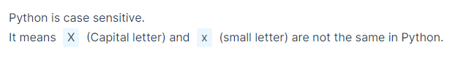

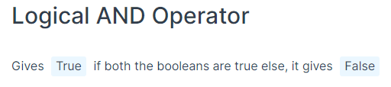

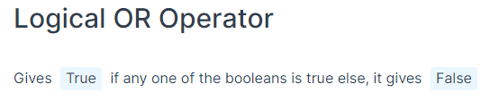

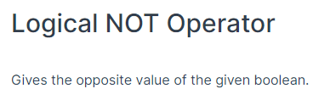

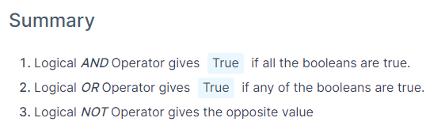

Nested if else syntax:

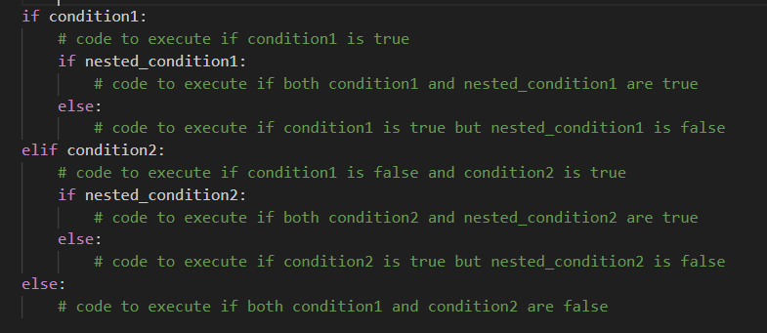

Nested if ellif syntax

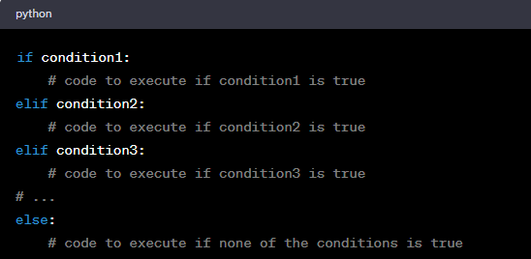

Loops:

For loop

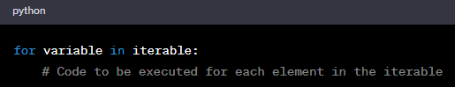

* Iterating over a list
* Iterating over a range of numbers
* Iterating over characters in a string
* Iterating over a dictionary

While loop syntax

* Variable declaration
* Condition
* Print statement
* Iteration

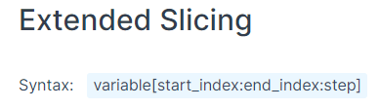

String methods

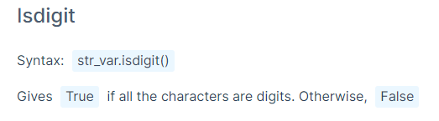

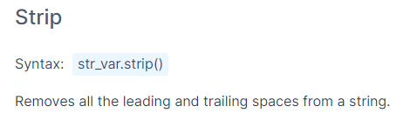

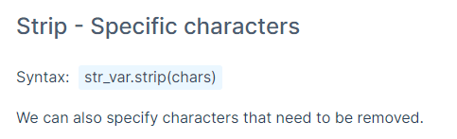

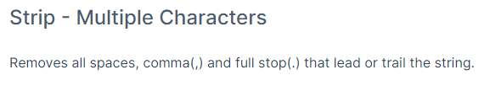

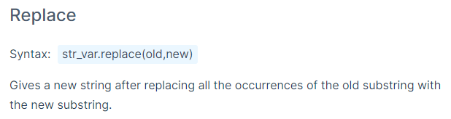

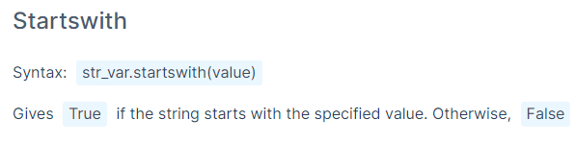

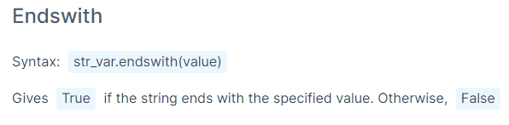

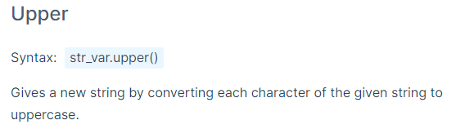

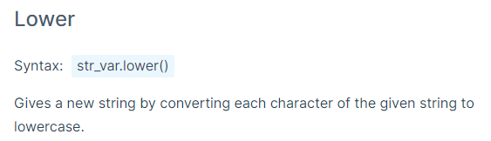

Classification Methods

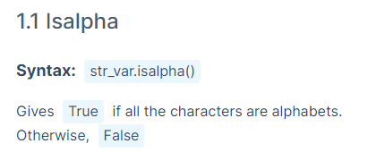

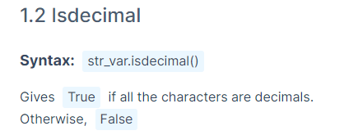

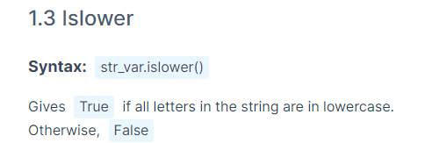

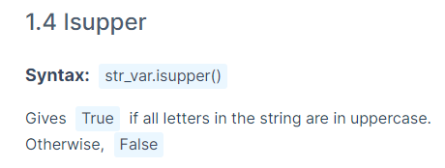

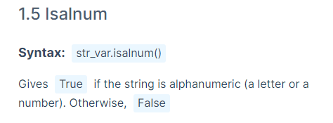

Case conversion methods

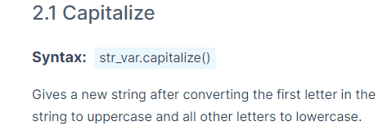

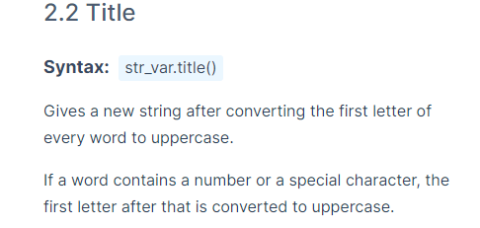

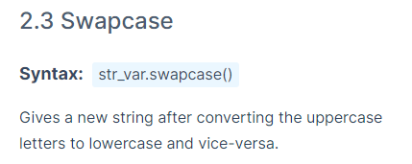

CONTINOUES $ SEARCHING METHODS

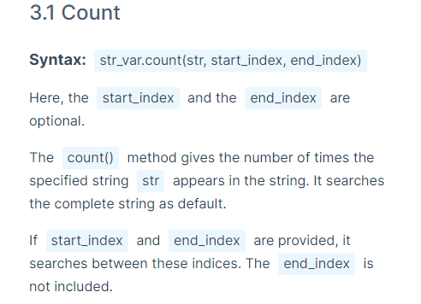

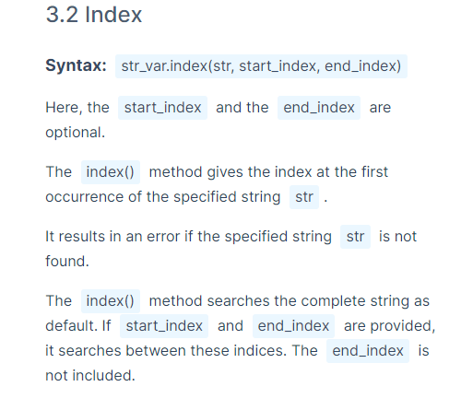

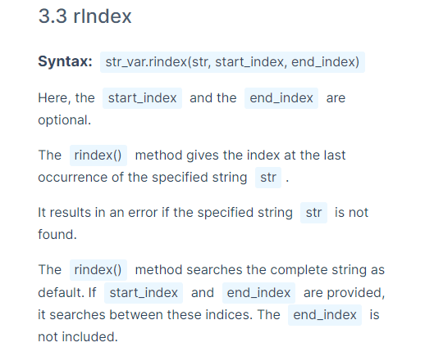

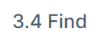

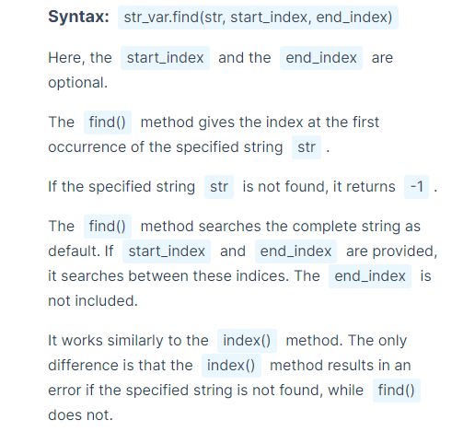

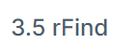

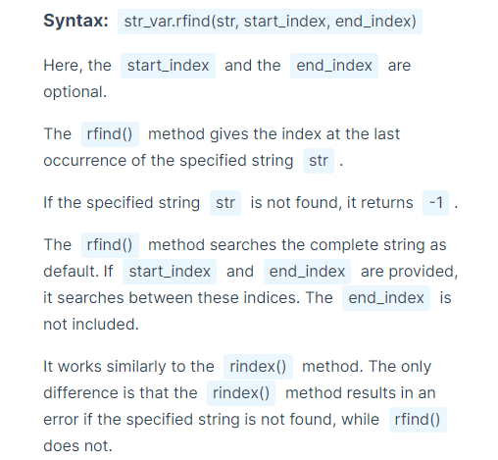

NESTED LOOPS:

NESTED FOR LOOP:

Syntax:

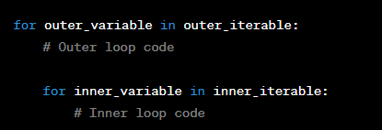

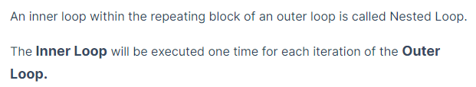

Outer loop condition satisfy aye antha varaku run avthundhi

Inner loop kuda condition satisfy aye antha varaku run avthundhi + outer loop iterate ayina prathisari inner loop run avthundhi

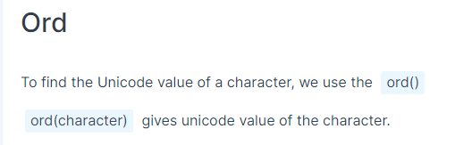

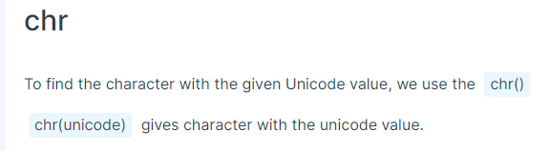

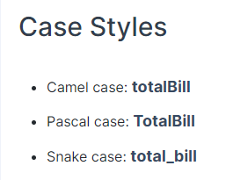

LIST:

* Create list
* Check type of list
* List lopala inko list ni pettu
* Length of list
* Access elements using List indexing
* Iterating over a list
* Operations on list like list concatenation, list repetition, list extended slicing
* Adding items to list
* Converting any data type to list
* Mutability concept in list & strings
* Update sequence of character in string

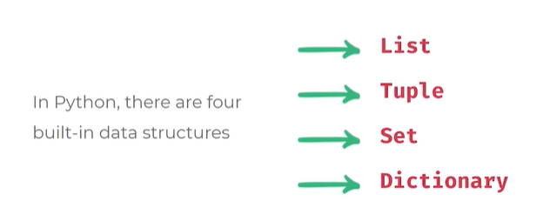

* Store,organize,access data structures

**LIST**

List is versatile data structure

Ordered sequence of data can include string data type, int, bool, float

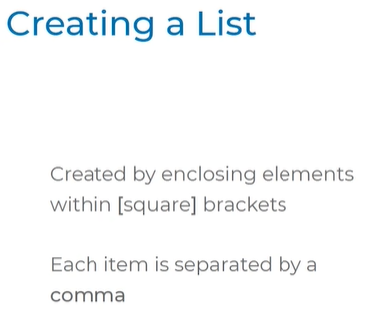

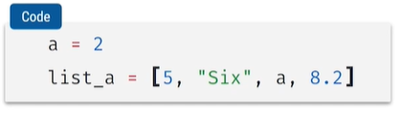

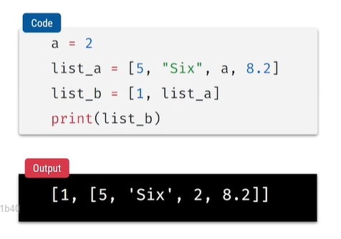

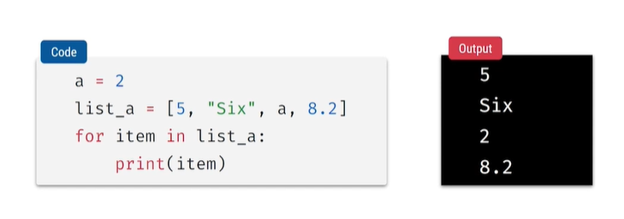

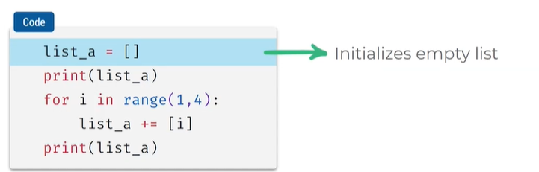

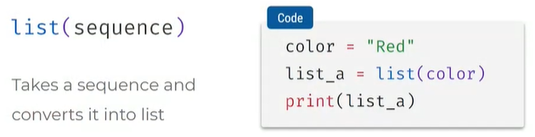

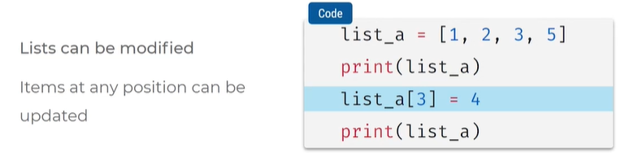

* Mutability – change cheyachu
* Immutability – change cheyalemu
* List is mutable, changed
* Strings are immutable , cant be modified or changed

WORKING WITH LIST:

* Identify object
* Refer same object
* Access elements with assignment operator

We will learn:

* Concept of objects
* Identity of an object
* Assigning vs modifying list

LIST & STRINGS:

Reverse a list

**Splitting & joining strings (split a string)**

* Split a string with spaces, muntiple spaces , new line, tab space
* Specify separator comma, space , single character , word

**Joining of Strings:**

* **We can add only for string sequence not for non strings like range, character**

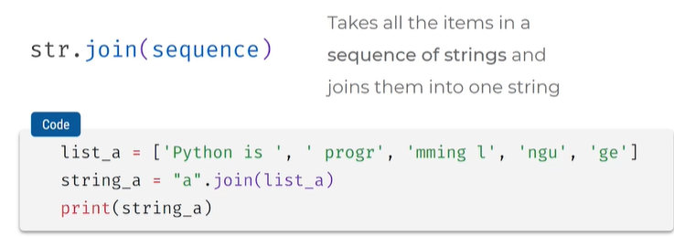

**Negative indexing**

* **Last index is not included**
* **Index can go out of length means out of range**

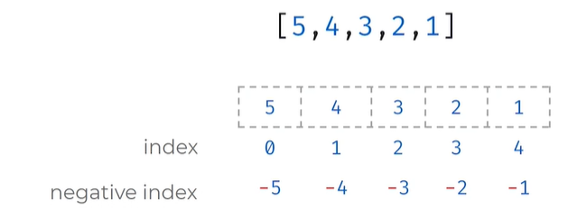

**Negative step in slicing :**

* **Start step should be bigger than end**
* **8 starts index 8**
* **End index 1**
* **Steps – 2**
* **8 nunchi 1 varaku 1 include avadhu -2 decrement by 2,8,6,4,2**
* **Not specified start index, end index, steps gets entire list**

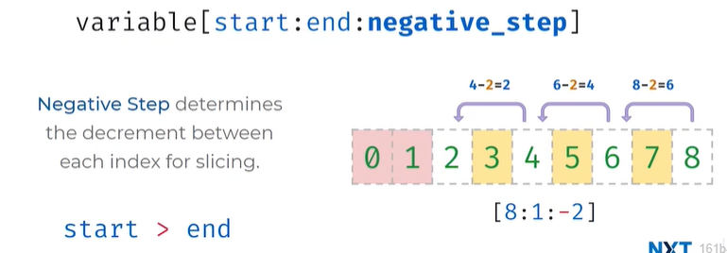

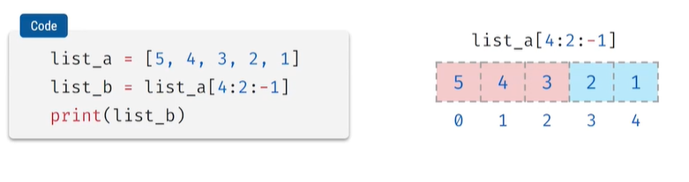

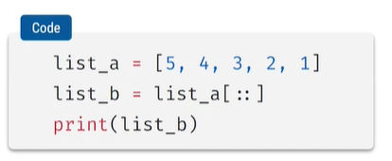

**Splitting a string**

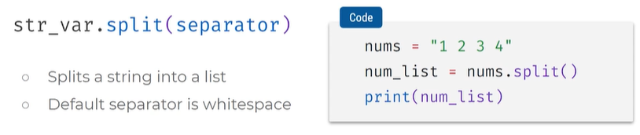

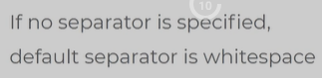

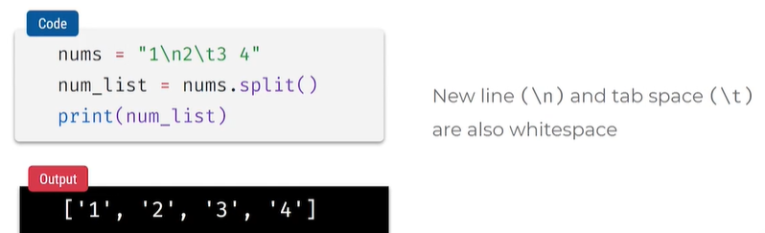

**FUNCTIONS**

**Defining & calling a function**

**Passing arguments in function**

**Return value in function**

Defining functions

Syntax:

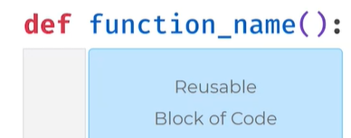

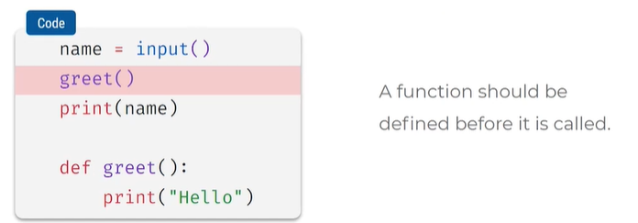

* Greet () lone msg ela pass cheyali?

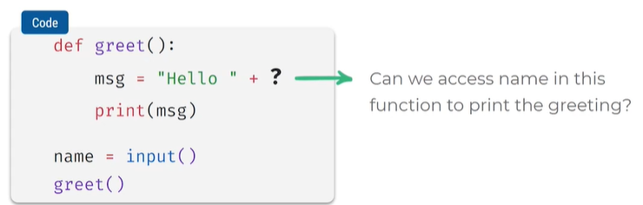

This can be achieved by passing arguments in function

Pass values to functions called arguments

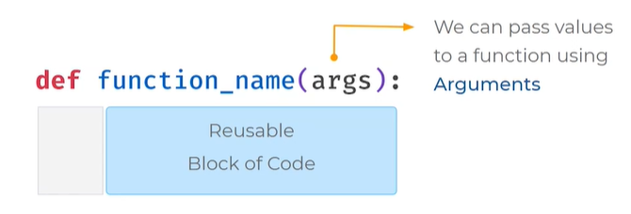

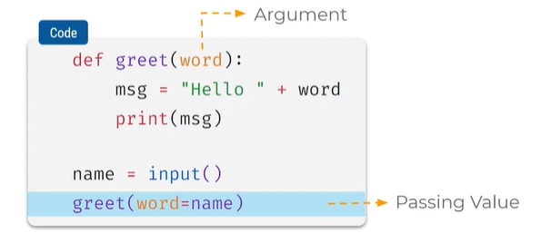

Return a value

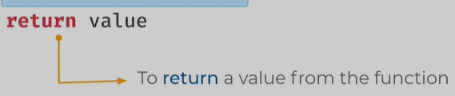

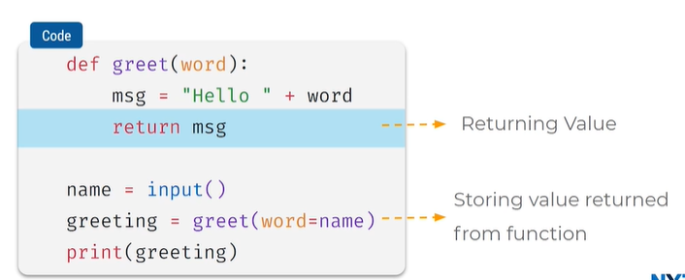

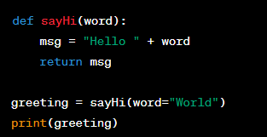

* If you want to return the value instead of printing it, you can modify your code
* the **sayHi** function returns the greeting message as a string, and you assign the result to the variable **greeting**. Then, you can print the **greeting** variable to see the message. When you run this code, it will print "Hello World" as the output.

Return print badhulu

Msg lo def lo pass chesina arg thiskuntamu

Def chesina function ni oka variable lo store cheskoni

Calling functions

Passing value arguments in functions

Return value in functions

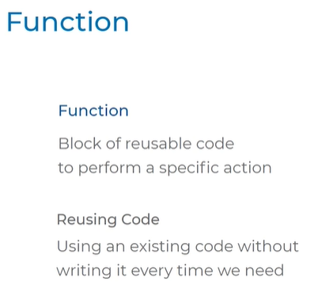

**FUNCTION ARGUMENTS**

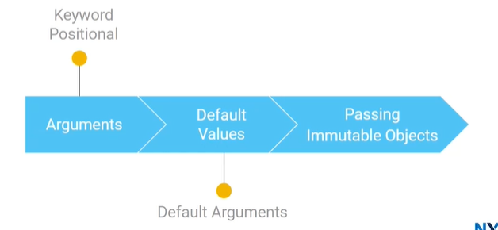

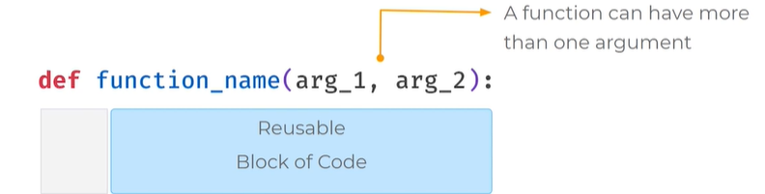

Arguments muntiple pettukovachu

Example:

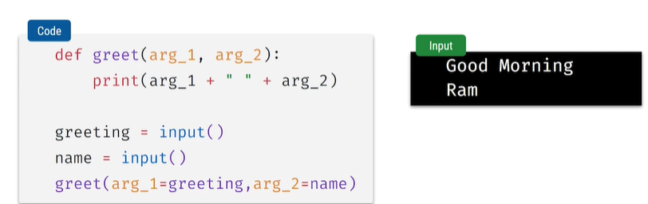

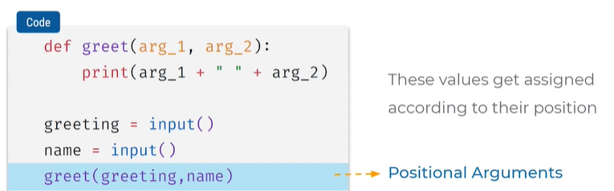

Arg_1 arg_2 lekunda straight ga greeting,name values assign chesam direct ga

Function ni call chese apudu values icham

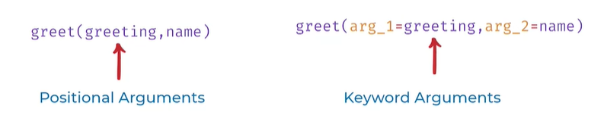

Default:

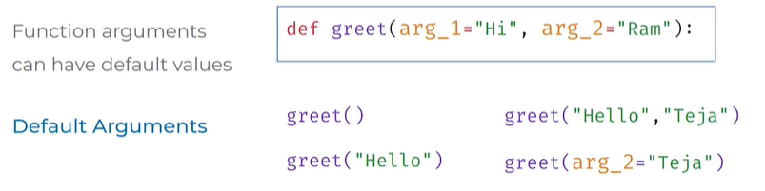

Def chese apude values ichamu arguments ki

NON-DEFAULT VALUES

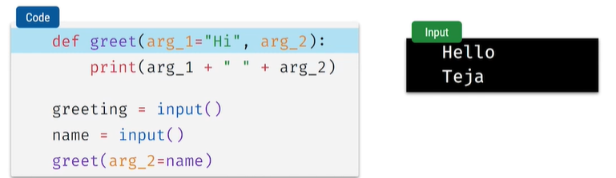

Arg_2 ki value ledhu so default adi

Default argument pakkana non default pedithe syntax error vasthundi

So non default value mundu pettali

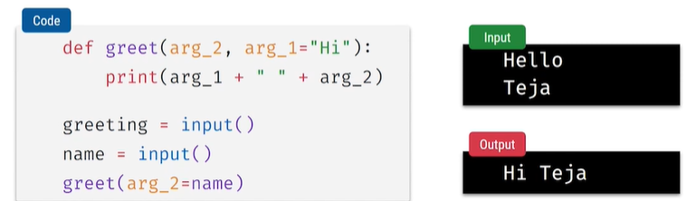

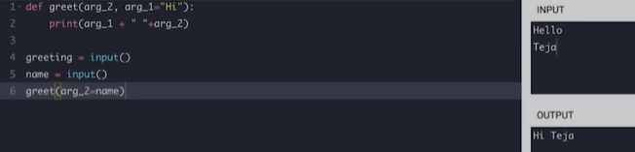

PASSING IMMUTABE OBJECTS

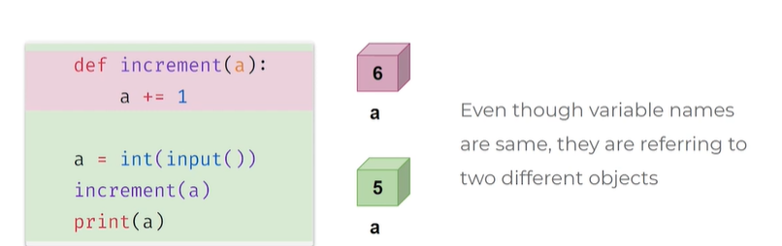

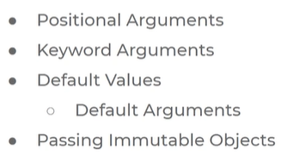

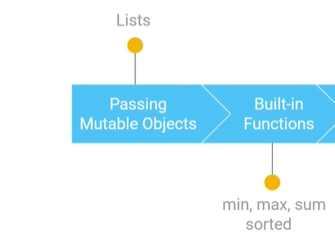

Function call chese apudu mutable object ni call chesthe?

Refers same list object when used += compound assignment operator in functions concept

Refers same list object when used arg add list refers new list object

Refers same list object with +=, arg add list ,

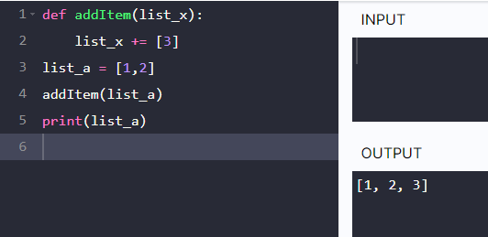

* addItem = function name
* list_x = argument
* compound assignment operator 3
* list_a lo value undhi
* function ni call chesam list_a variable tho
* print chesam
* ekkada list_a and list_x rendu refers the same list object

DEAFULT VALUE = pass empty list object when defining function

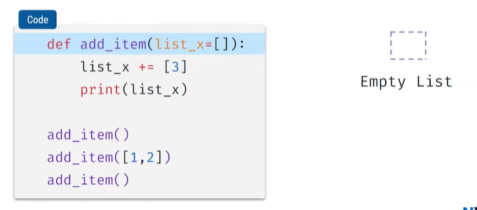

* default value laga oka empty list peduthunnam fun def lo
* empty list pedithe func lo oka empty list object create ayindi
* add_Item() function call chesam
* list object ni pass chesam add_item([1,2])

empty list object okasari matrame create avthundi,

BUILT-IN-FUNCTIONS IN PYTHON:

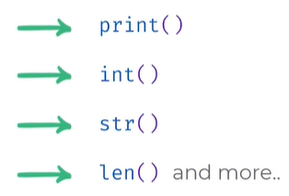

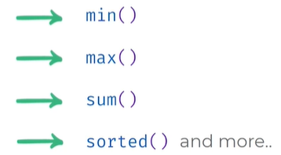

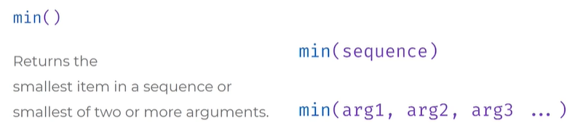

Returns smallest arg value = min

Returns largest arg value = max

Returns sum of arg value = sum

Sort: sorted()

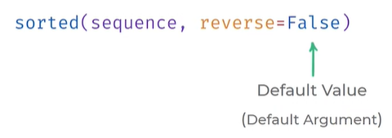

Increasing order

Ascending order = small to big

When reverse true desending order will come big to small

**FUNCTION CALL STACK & RECURSION**

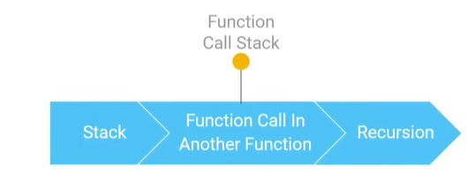

Data structure: data ni ela organize cheskuntundi ani meaning

Stack: It is a data structure

Stack Spl/behavior: last in & first out

Stack eg : plates

Last = first bayatiki vasthundi

Frist = last bayatiki vasthundi

Nested function= oka func lopala inko fuc ni call cheyatam , vere fun ni call cheyatam, indulo last function first execute avthundi, first func last execute avthundi

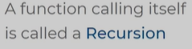

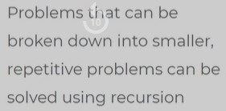

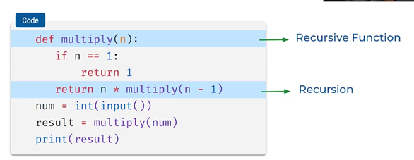

Muntiply ane function ni functional block of code lo malli call chesam

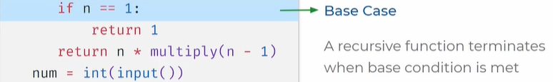

* infinity recursive okachota agali dani apadaniki condition pettam n value one ayithe recursive aagipovali
* base case lekapothe error vasthadi

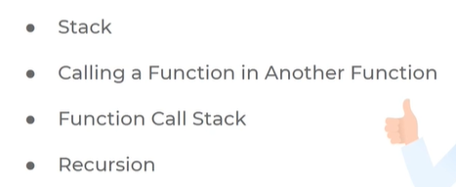

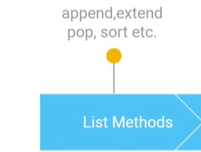

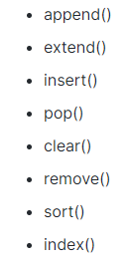

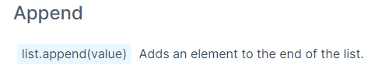

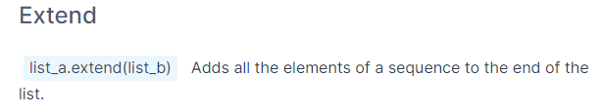

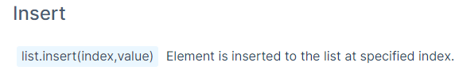

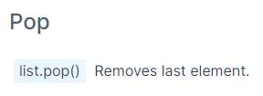

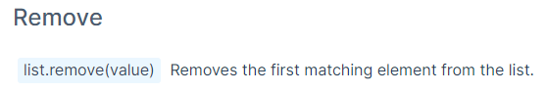

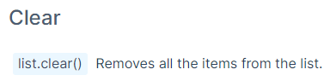

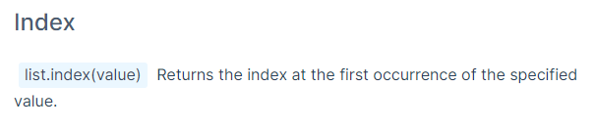

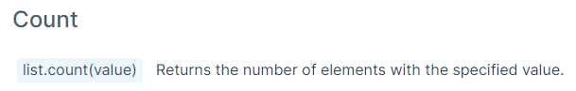

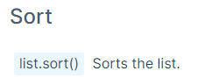

**TUPLES & SETS**

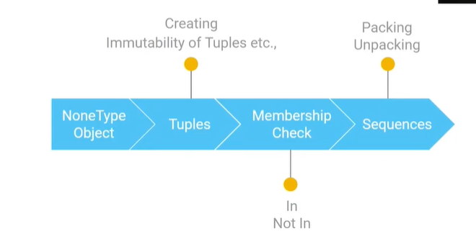

None type object

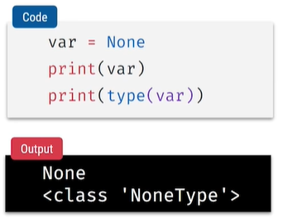

* variables ki value none type kuda ivachu
* none ante no value
* type is none type
* To represent no value use none type

Function with no result

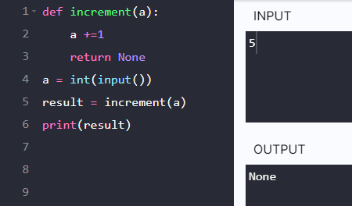

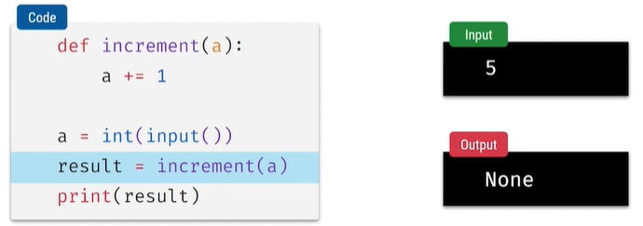

* Function lo return statement ledu
* Increment function call chesinapudu ah function lo statement execute avthundi kani output none because no return statement
* Function em return cheyadu

Return pedithe value 6 vasthundi

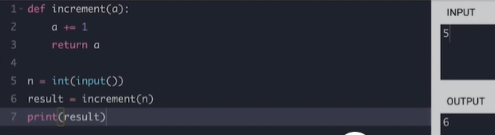

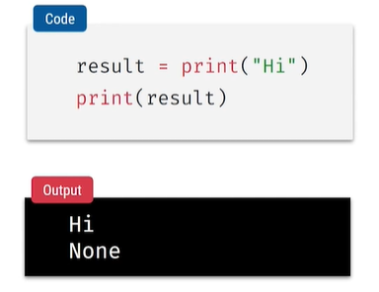

Tuples data structure, creating tuples, immutability of tuples

* List = mutable []
* Tuple = immutable ()

Creating Tuples

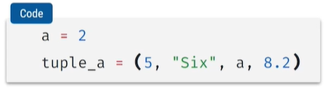

* We use round braces
* Separated by comma
* a is variable name

Check data type of tuple

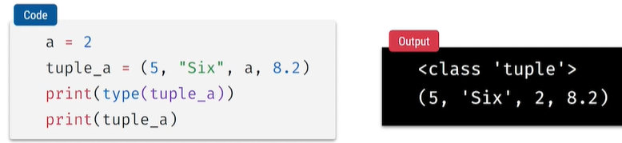

* Type of tuple

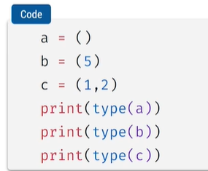

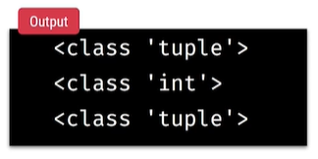

* Created empty tuple
* 5 is a single value which is integer not tuple , string

 this is a tuple type

* 1,2 tuple with 2 elements

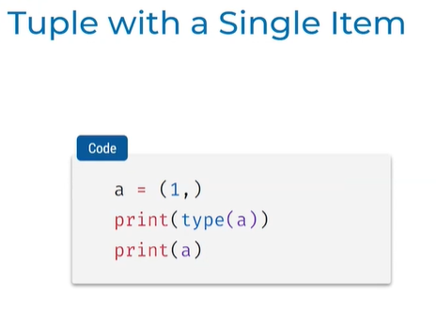

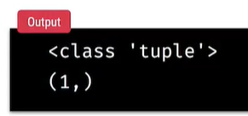

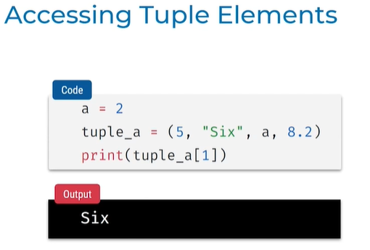

Tuples are immutable

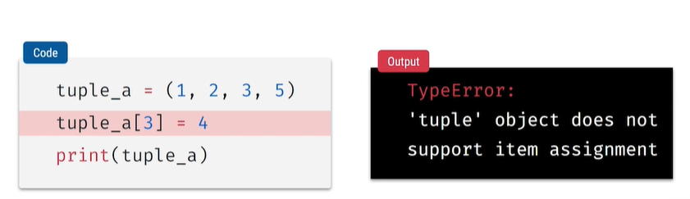

Operations on Tuples

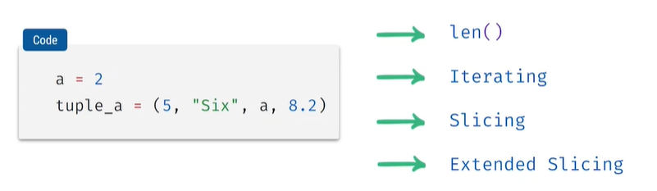

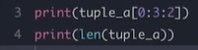

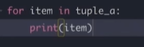

CHNAGING ANY SEQUNCE TO TUPLE:

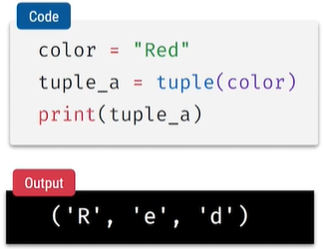

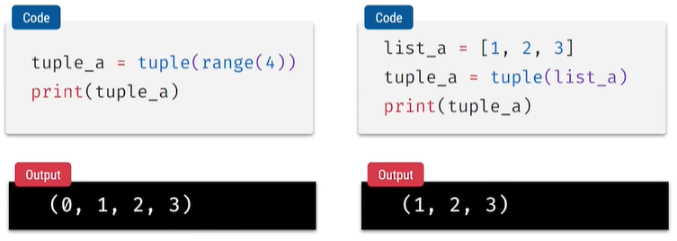

Membership check – in, not in operator

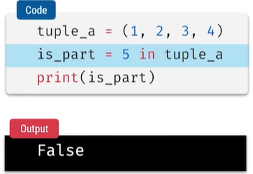

* In ane operator 5 value tuple lo undha ledha
* Unte true lekapothe false

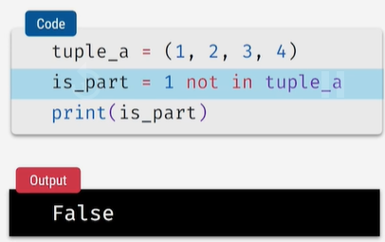

* 1 not in tuple which is false
* Undhi 1 tuple lo

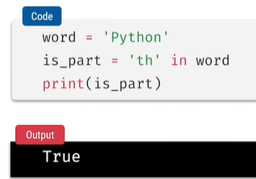

Pacing unpacking & packing concepts in Sequences

Unpacking :

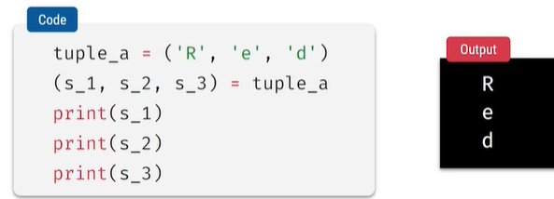

* Printing independent variables
* Unpacking can be used in list & strings

List

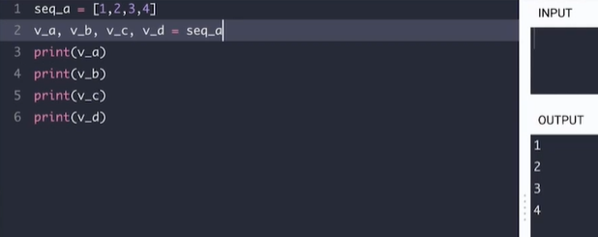

String

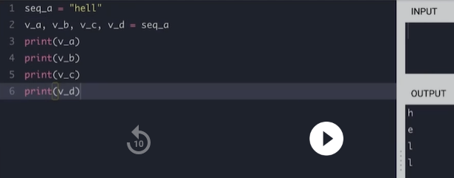

Packing Tuple:

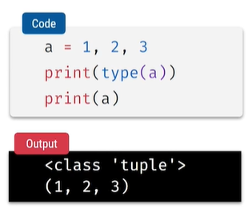

* Round braces pettakunda comma tho separate chesthe output tuple ane vasthundi

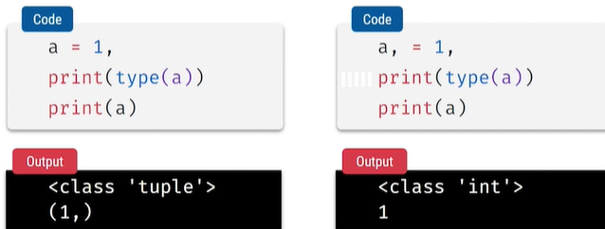

PACKING & UNPACKING

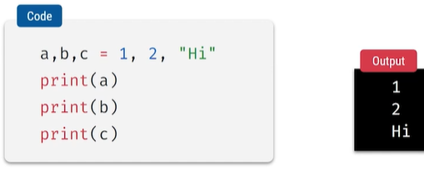

* 1,2,Hi tuple packing = a,b,c tuple unpacking

Return muntiple return values in functions

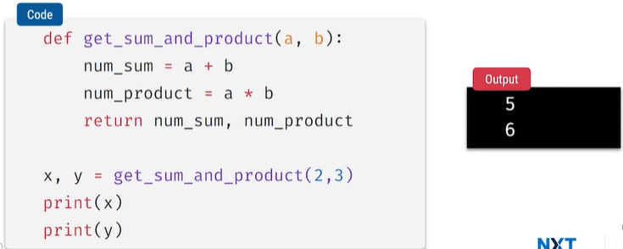

Return lo multiple values isthe oka tuple laga packing avthundhi

a,b are 2 argumnets given in def function

values 2,3 tho call chesam

**SETS**

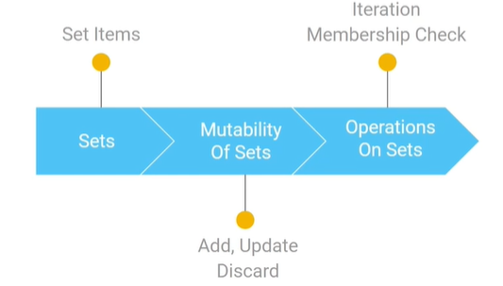

Set data structure

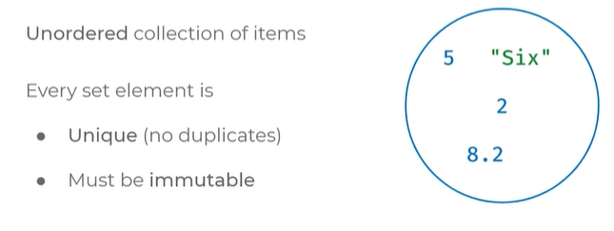

* Set is a unordered collection of items , no position for elements
* Oka element multiple times undadu
* Unique elements no repetition of same data
* Immutable so can add tuple,integer, string
* can’t add mutable like list

Set items

Create a set

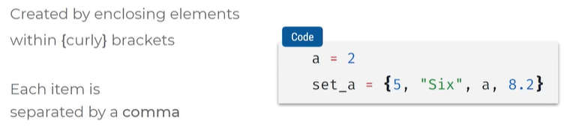

* Output is random order won’t be exactly the same order

Creating empty set

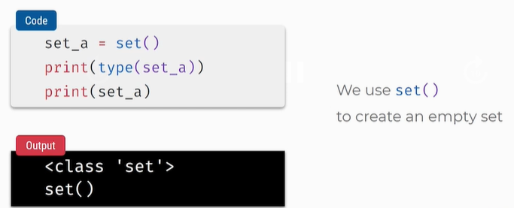

* No flower braces keep round braces to create an empty set
* Set()

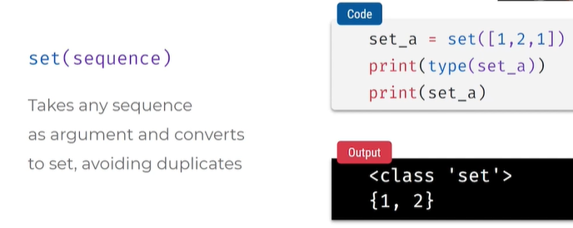

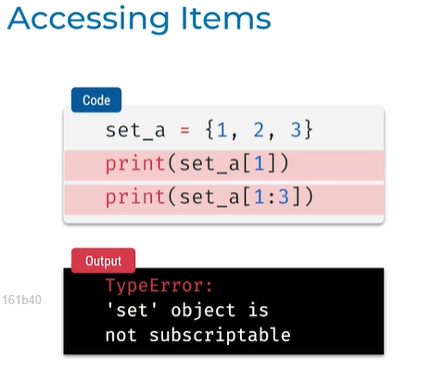

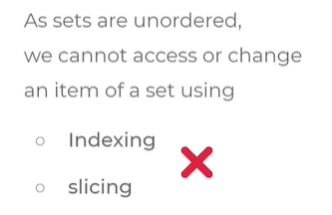

Adding items:

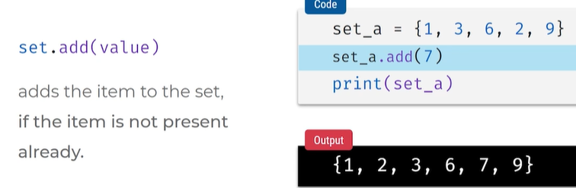

Add multiple items

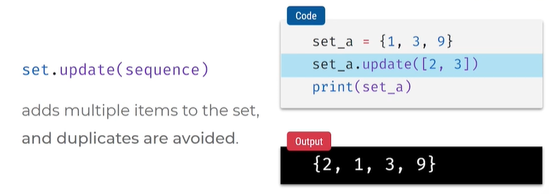

Remove specific item:

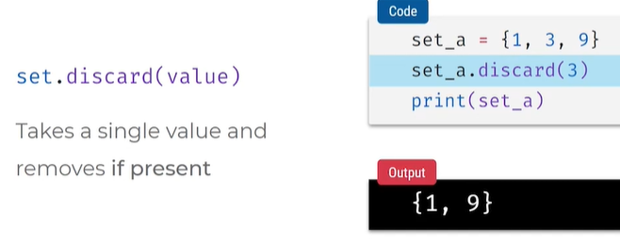

Discard kakunda remove ane method kuda use cheyachu

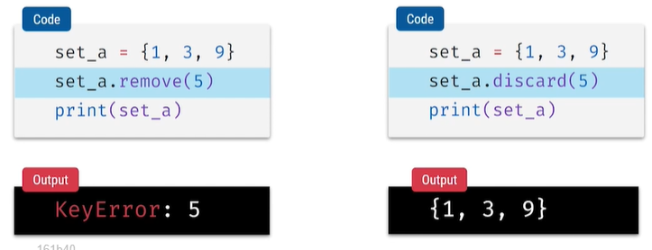

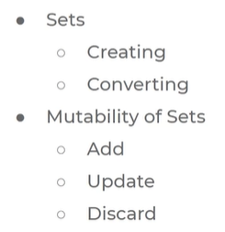

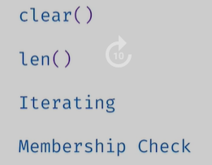

**SET OPERATIONS**

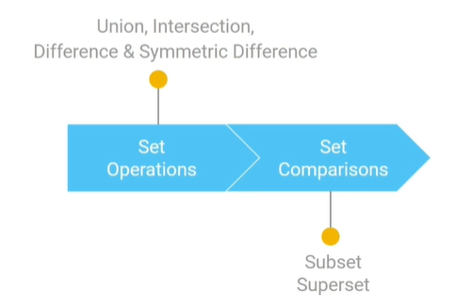

**Set operations**

Union

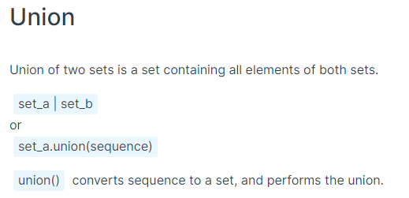

Intersection

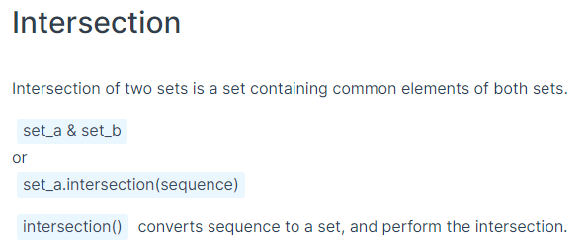

Difference

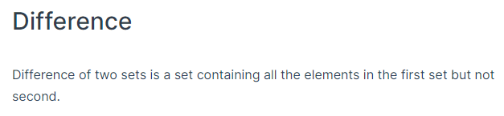

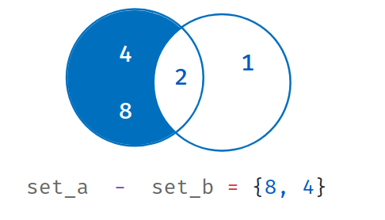

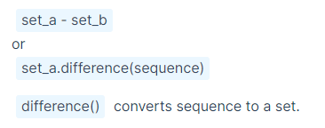

Symmetric Difference

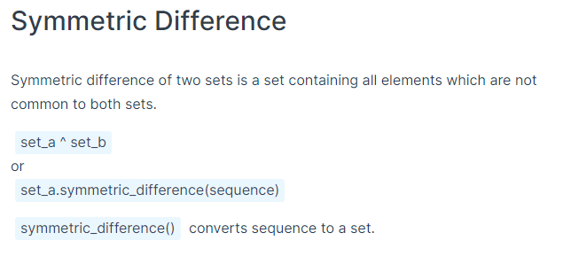

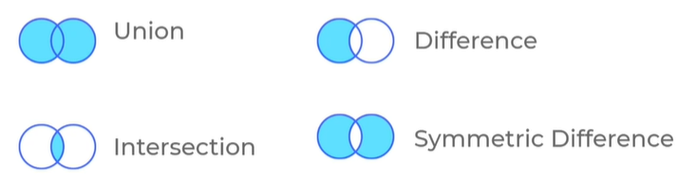

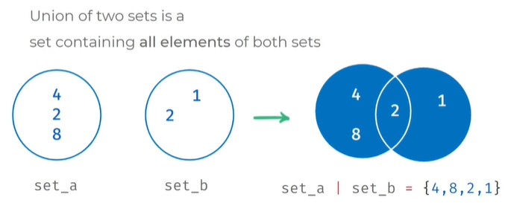

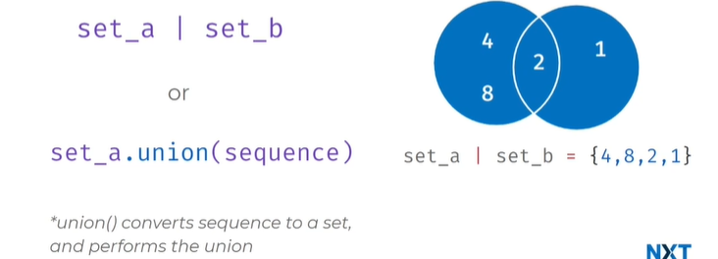

* Pipe symbol use chesthe set a union set b , pipe symbol use chesthe 2 sets ni union cheyachu
* 2 rendu sarlu undi adi repeat avvala
* Set a and set b elements untayi kani duplicates ravu unique values vasthayi
* Can union with sequence , seq is a set,

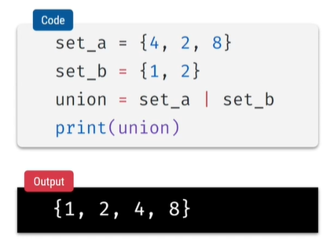

SEQUENCE EXAMPLE:

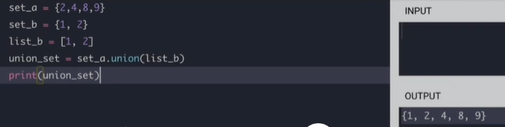

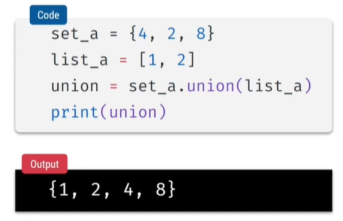

INTERSECTION = amber cent or and symbol

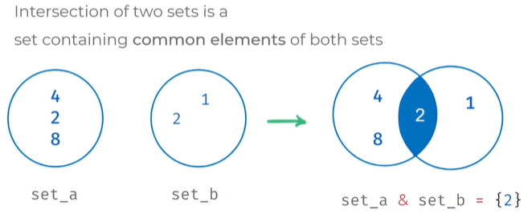

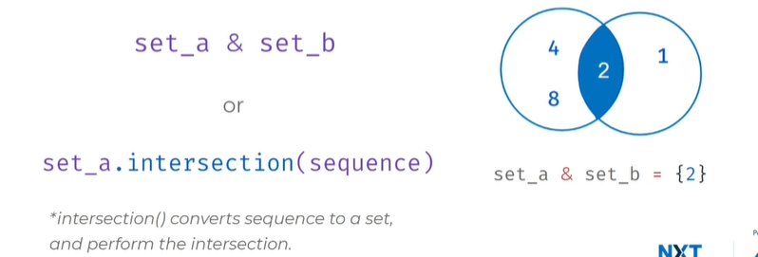

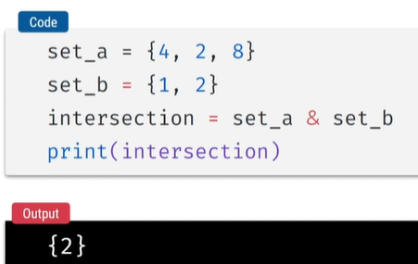

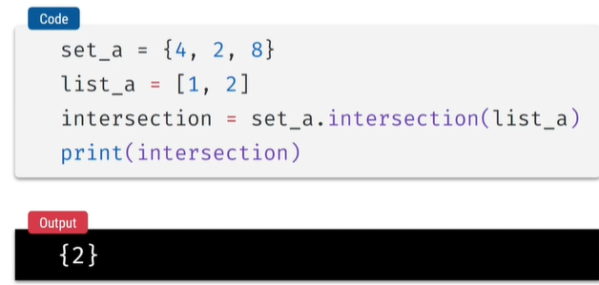

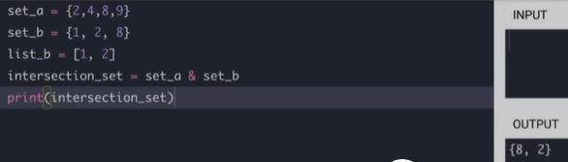

SEQUENCE EXAMPLE

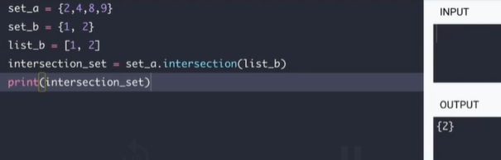

DIFFERENCE:

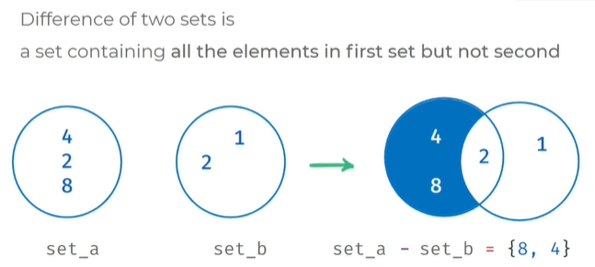

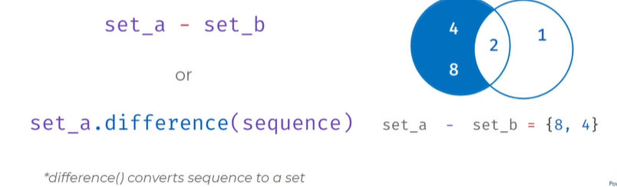

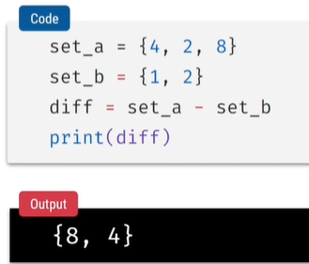

EXAMPLE WITH TUPLE VALUE:

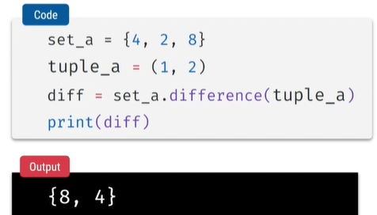

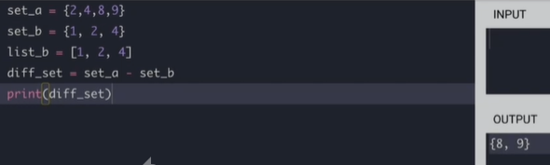

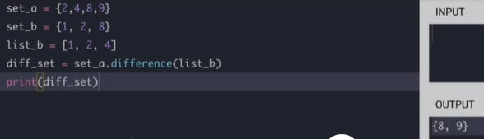

SYMMETRIC DIFFERECE

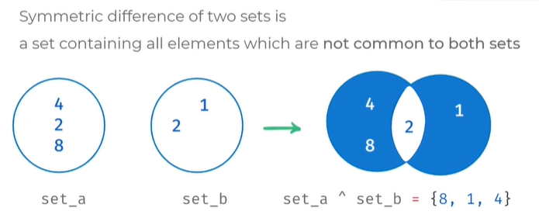

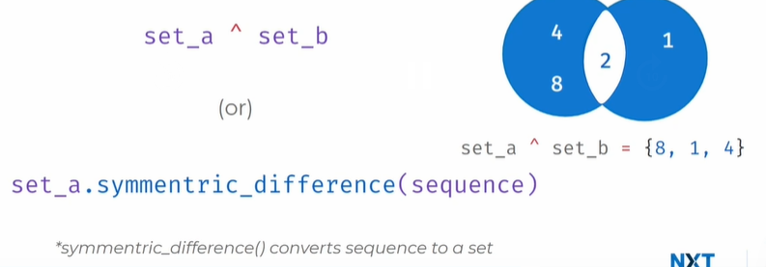

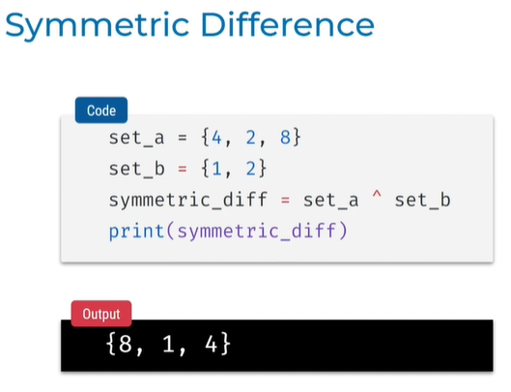

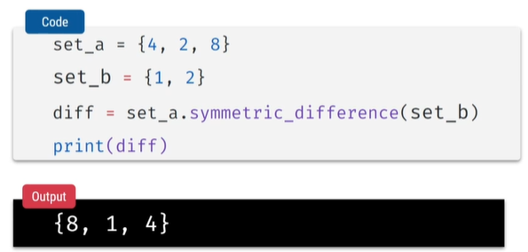

**Set comparison**

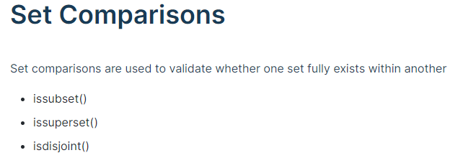

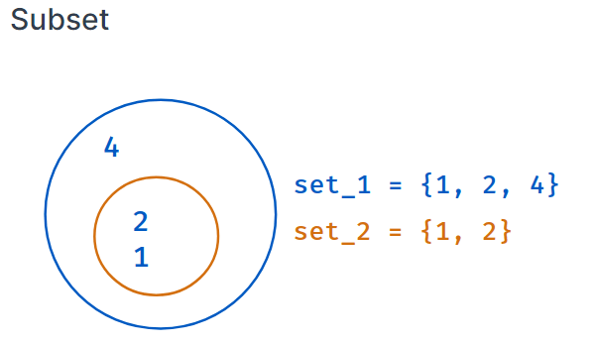

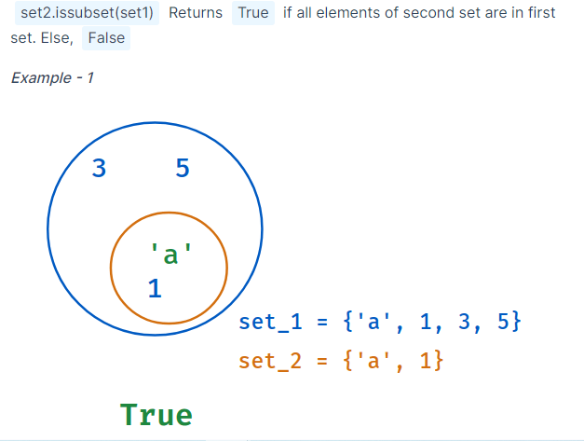

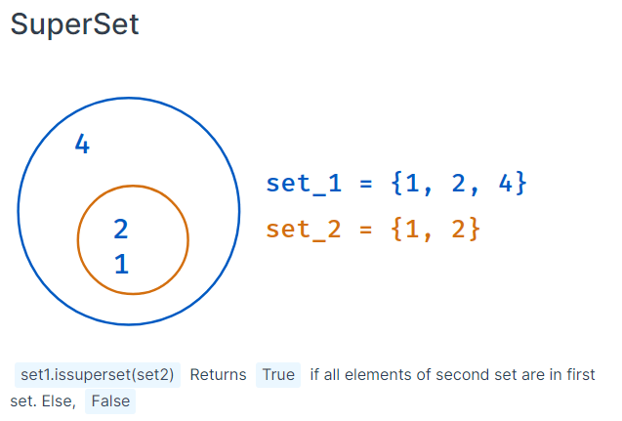

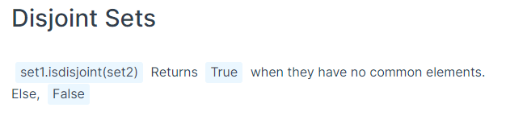

Subset

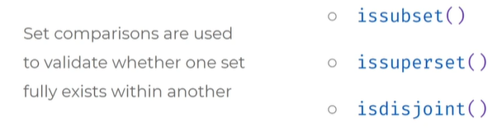

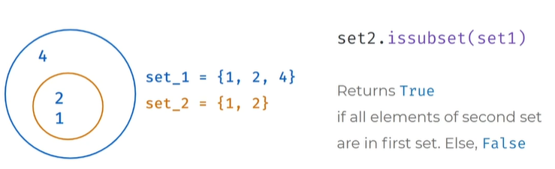

Set_2 is subset of set_1

Set2 lo unna values set1 lo unnayi ante TRUE lekapothe FALSE

Oka set lo unna values inko set lo unnayo ledo compare cheyachu

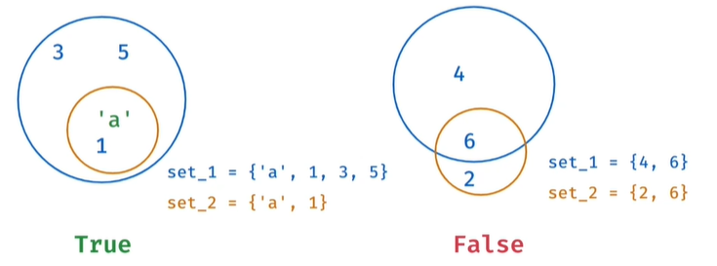

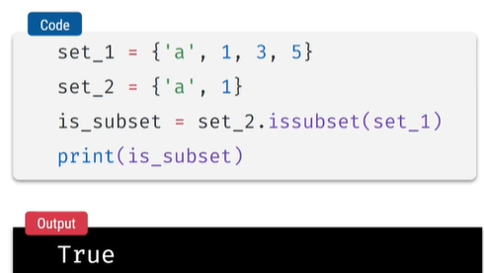

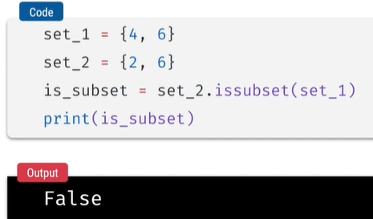

Superset

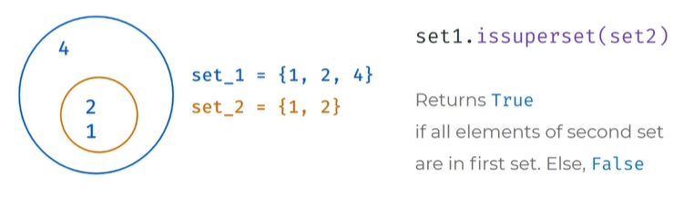

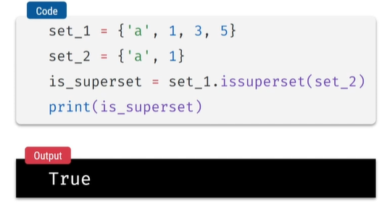

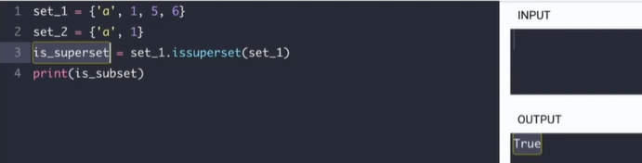

Disjoint

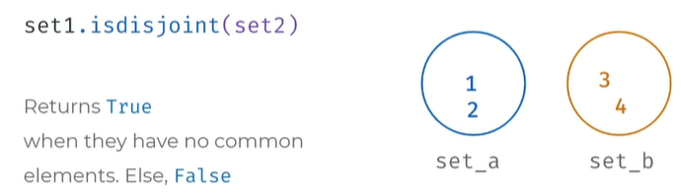

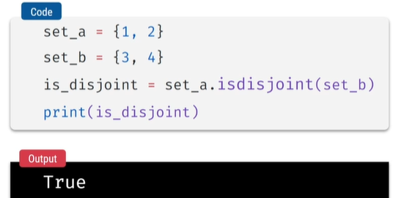

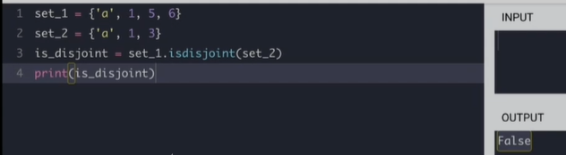

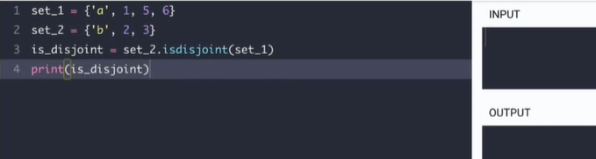

**DICTIONARIES**

Nested list - single list nested, double list nested

Nested list in Tuple

Nested list in Strings

Access items in Nested list, Nested Tuple, Nested String

*******************************

String Formatting with string type conversion

String Formatting with placeholder

String Formatting with number of placeholder

String Formatting with numbering placeholder

String Formatting with naming placeholder

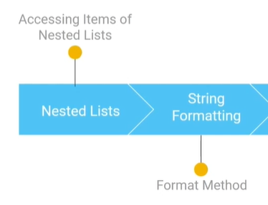

Nested List

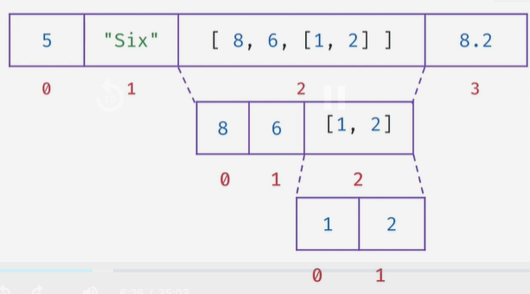

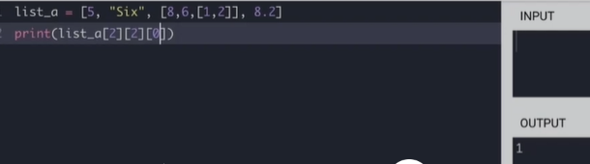

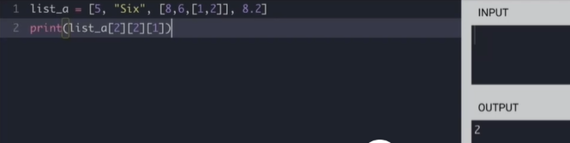

Nested Tuple in list , Nested String in list

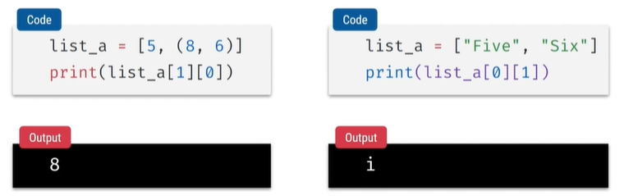

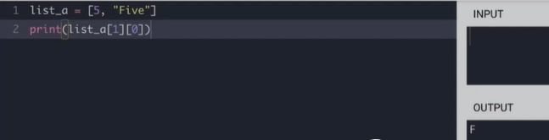

Access items in nested list

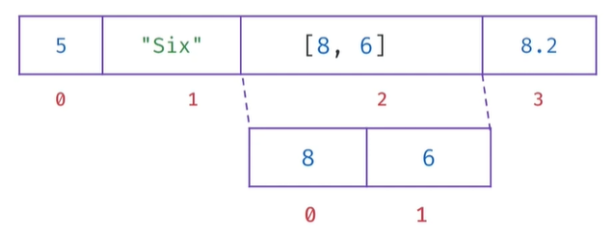 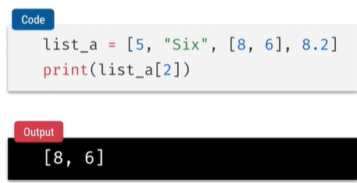

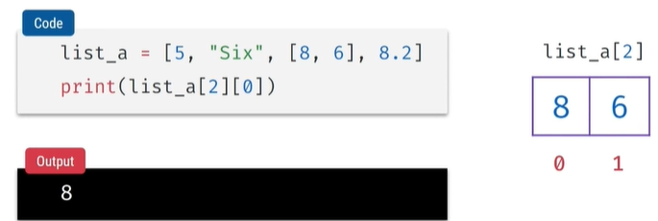

String formatting

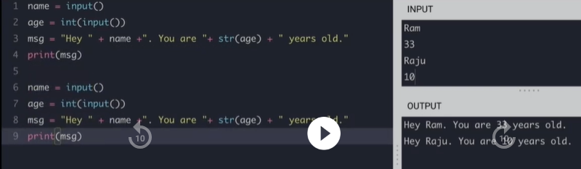

The simplified form the above improves readability, easiness, no need type conversions

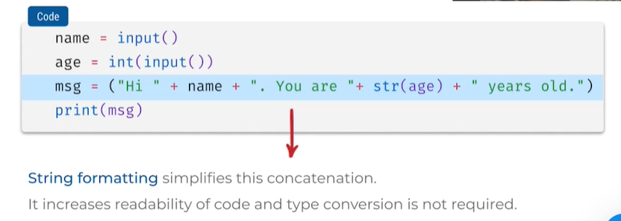

Format method in string formatting with placeholder {}

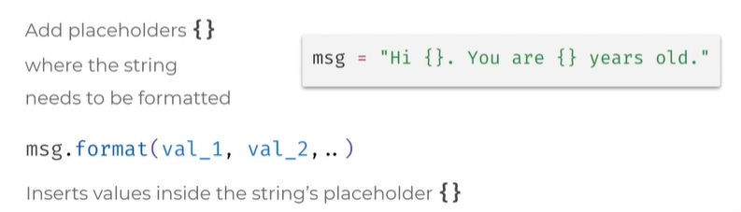

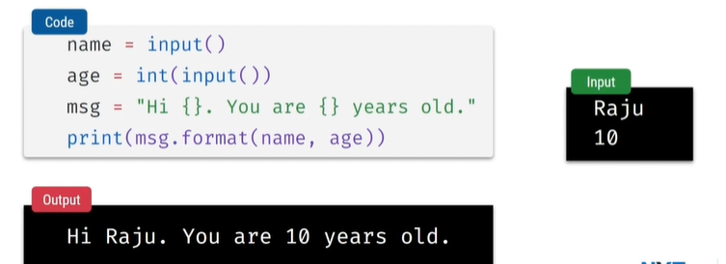

DIFFERENCE:

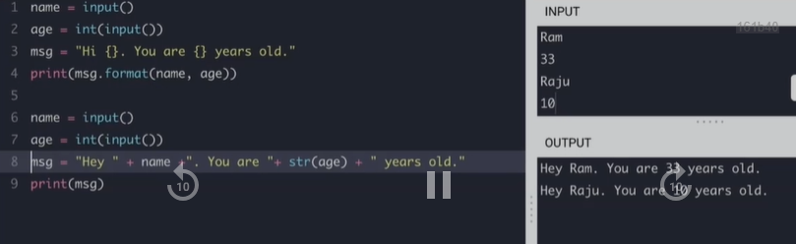

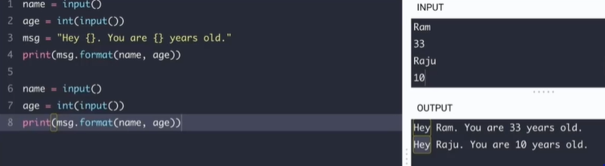

NUMBER OF PLACEHOLDERS

* Gives index error out of range

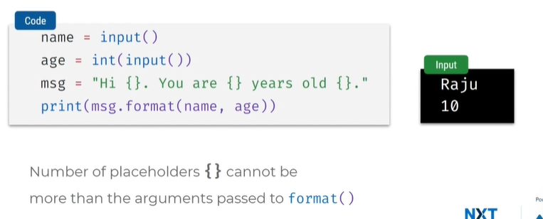

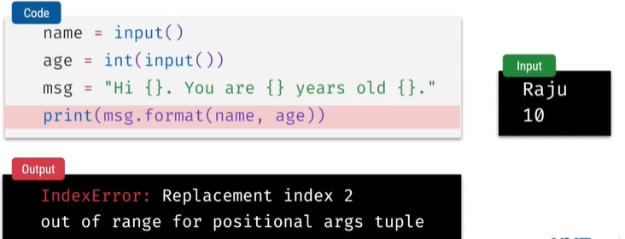

NUMBERING PLACEHOLDERS

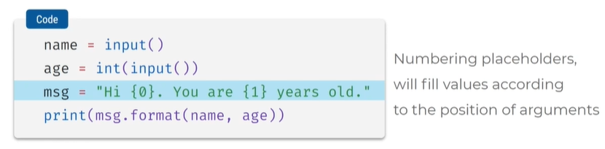

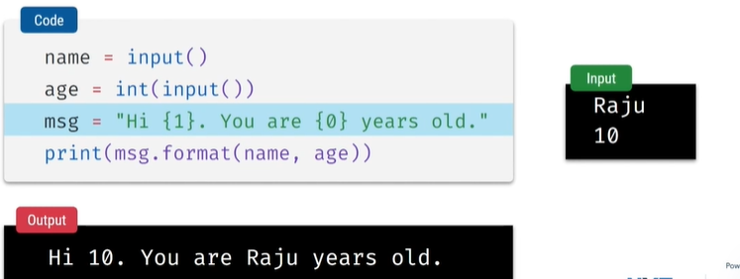

NAMING PLACEHOLDERS

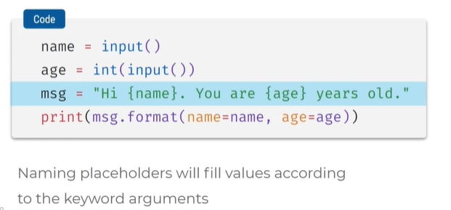

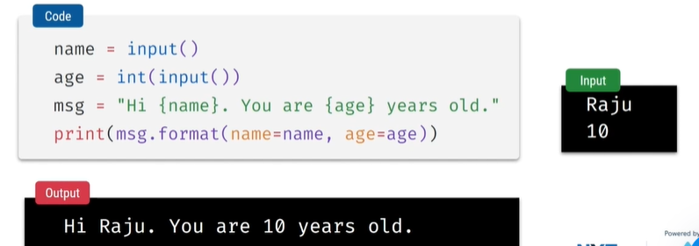

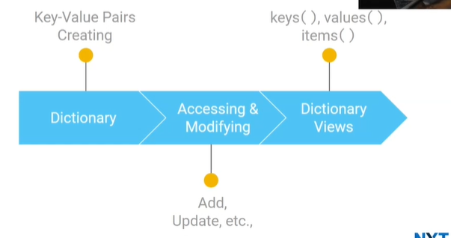

Dictionary is type of data structure

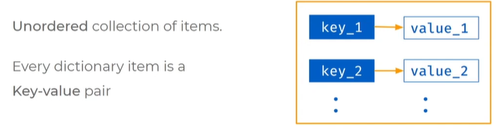

* Every item has key and value

How to create dictionary

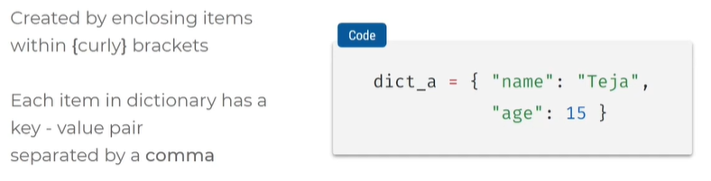

* Key and value is separated by colon name is key and teja is value separated by comma
* Combination of key and value is called item
* Multiple items are kept by comma
* Flower braces are used for each key value pair

Check the typeOf

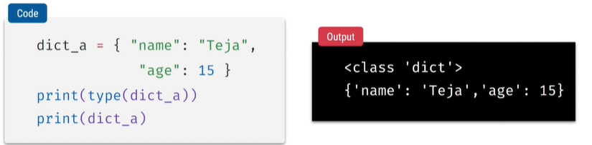

DIFFERENCE BETWEEN DICTIONARY & SET

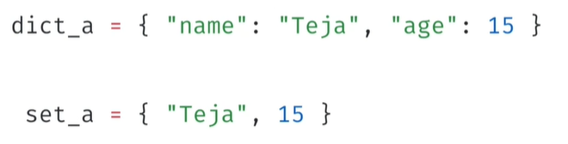

* Set lo only values untayi
* Dictionary lo each item ki oka key, value, colon, coma untayi
* Flower braces use chestham set lo dictionary lo

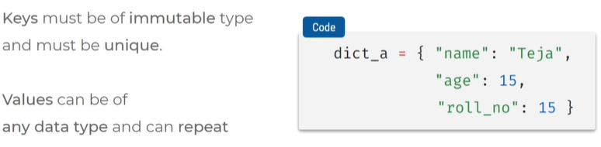

* Keys unique ga undali , same names undakudadhu , repeat avvakudadu , immutable, modify cheyalemu
* Values mutable undachu, repeat avvachu,mutable modify cheyachu

Create empty dictionary :

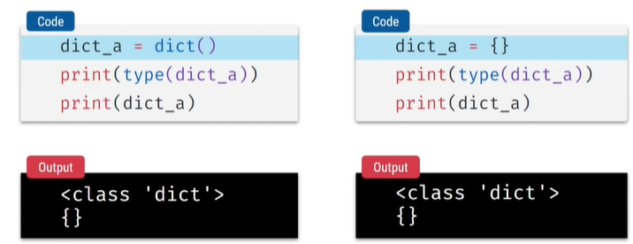

* Dic()
* Dic{} empty flower braces

How to access items from dictionary

* Indices = index use cheyalemu

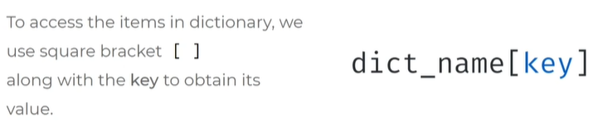

One method to access: square braces

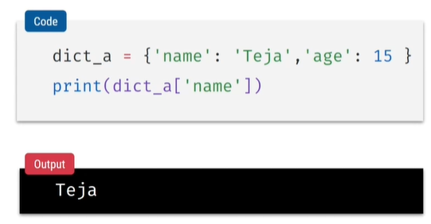

Second Method: get()

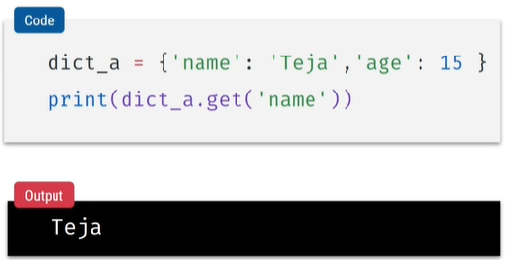

DIFFERNCE B/W SQUARE BRACES & GET OF

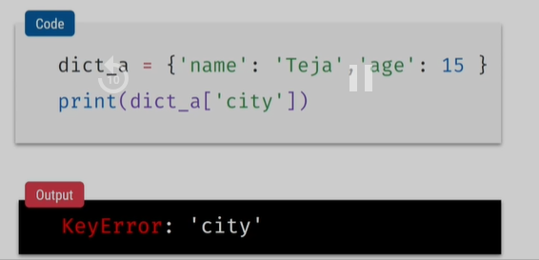

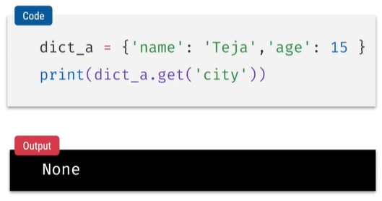

Membership check in dictionary:

* perform on keys don’t perform on values it gives false even though it exist

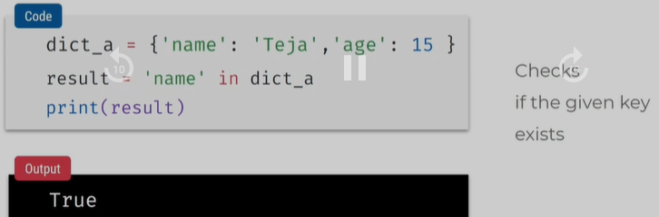

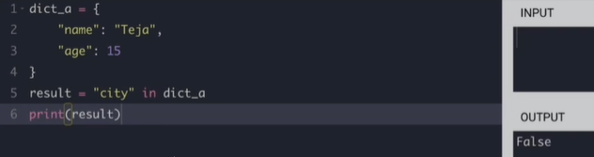

OPERATIONS ON DICTIONARIES

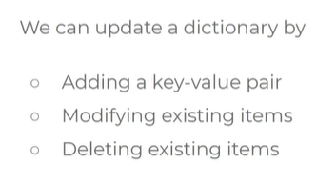

* Add a key value
* Change existing key value
* Delete whole item

Add a key value

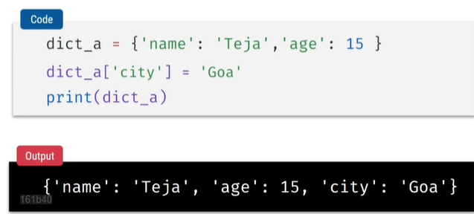

Change existing key value

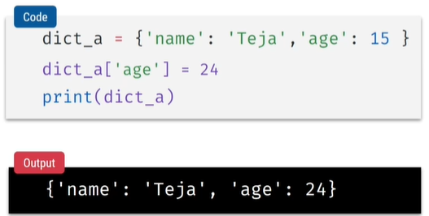

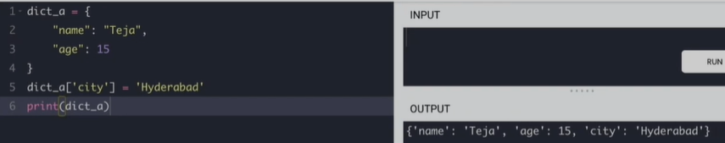

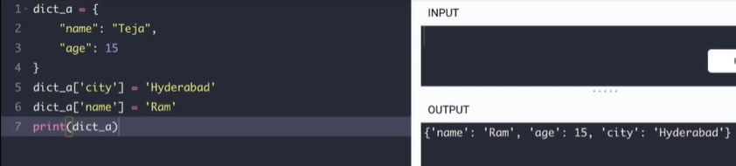

Delete whole item

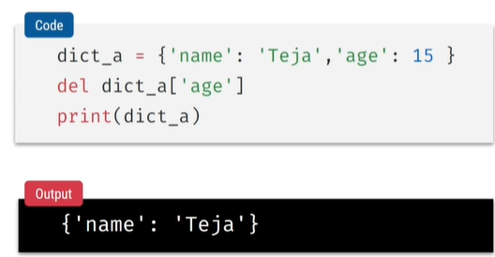

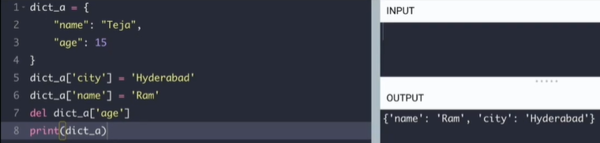

**DICTIONARY VIEWS**

Dictionary Methods:

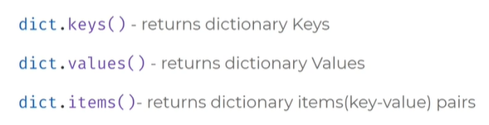

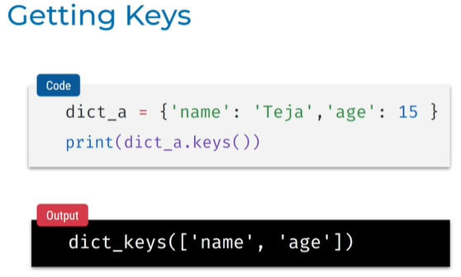

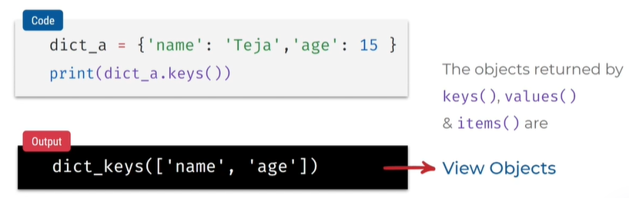

In view Objects we can iterate , iterate chesthe only key values print avthayi,

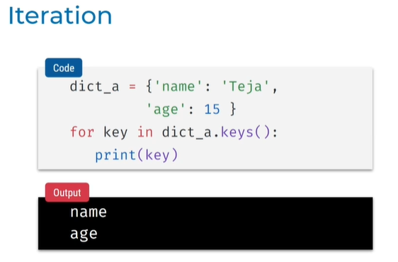

CONVERT TO LIST

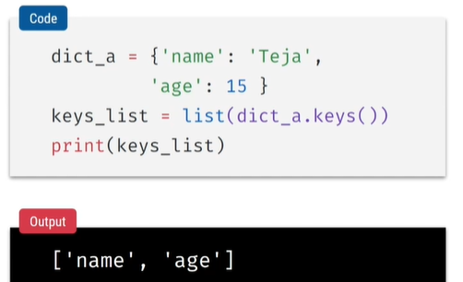

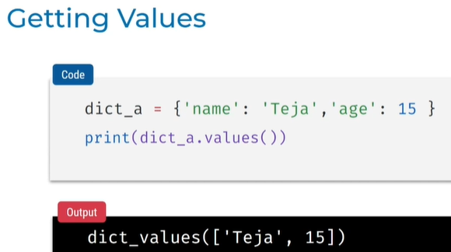

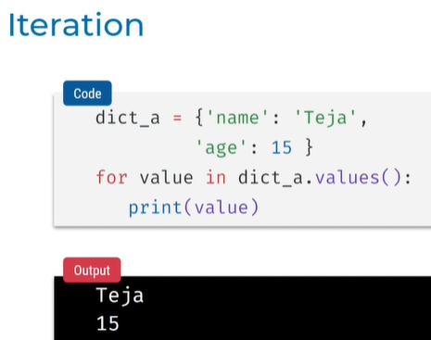

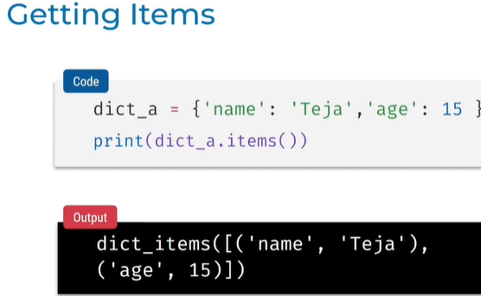

* Comes in the form of Tuples

Tuple unpacking

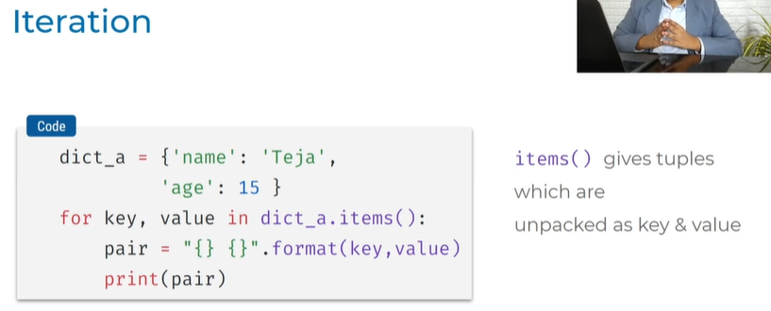

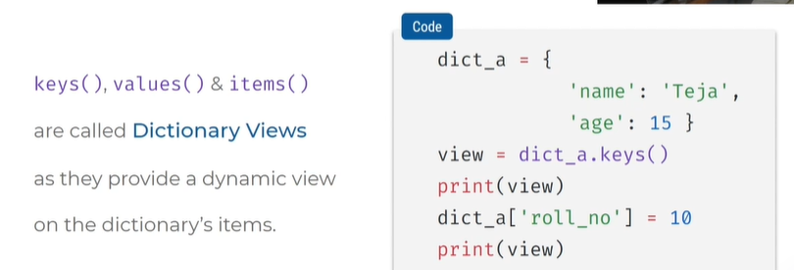

WHAT IS DYNAMIC VIEW

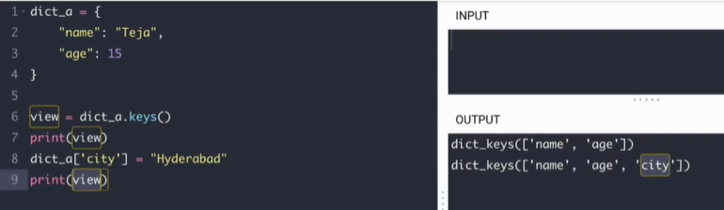

* View lo keys anni add chetshunnam
* City add chesam
* Dynamic ga add ayindi

CONVERTING TO DICTIONARY

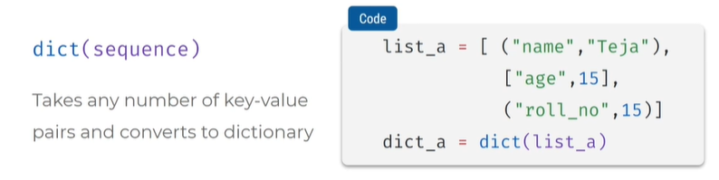

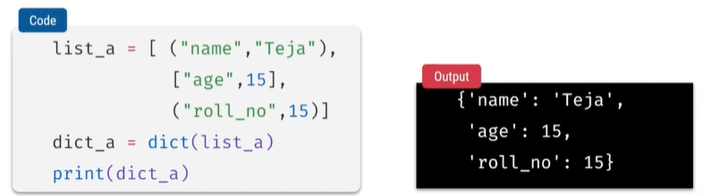

**WORKING WITH DICTIONARIES**

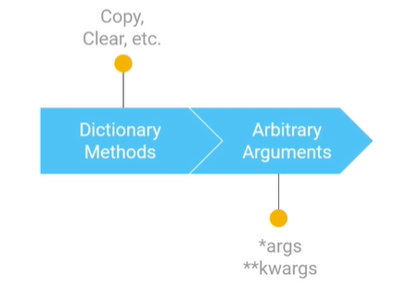

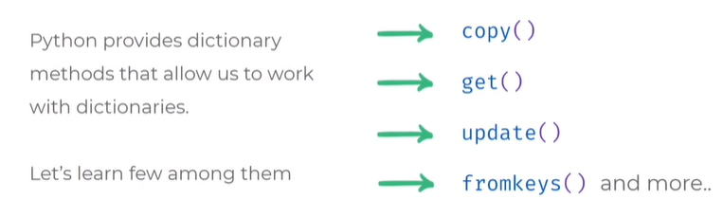

REFER SAME DICTIONARY OBJECT:

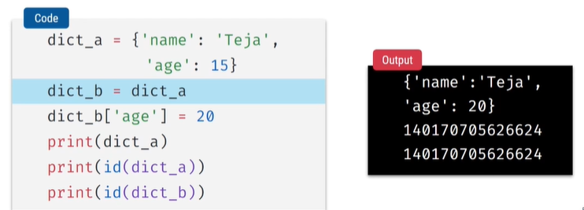

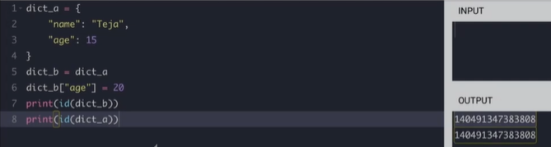

COPY OF METHOD:

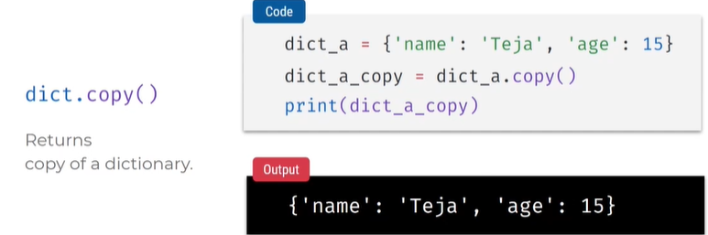

COPY METHOD DIFFERS OBJECT DIFFERENT ID’s

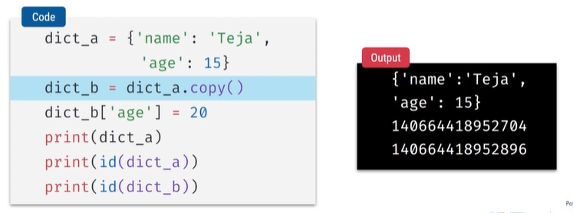

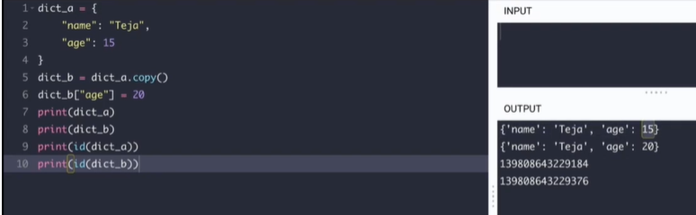

NOT ONLY COPY DICT WE CAN ALSO COPY LIST

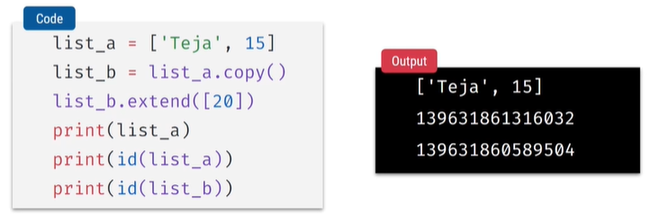

* 2 variables different objects ni refer chesthunnai

OPERATIONS ON DICTIONARY

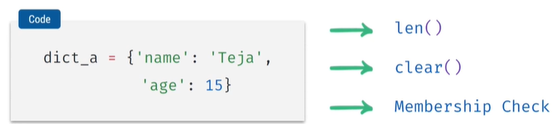



Clear = empty dict

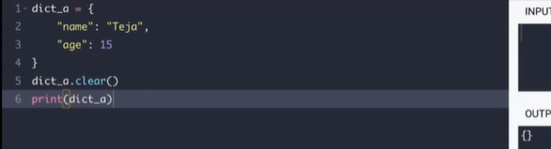

Iterating:

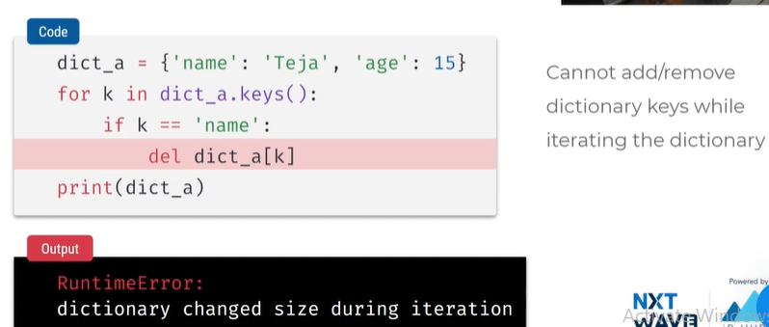

* Don’t add or remove when iterating

**ARBITUARY FUNCTIONS ON ARGUMENTS**

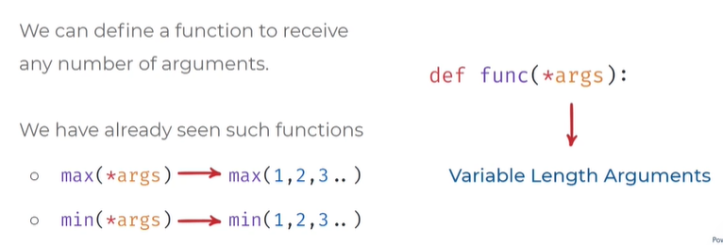

Pass multiple arguments = *args

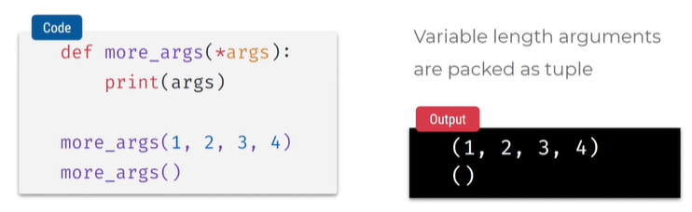

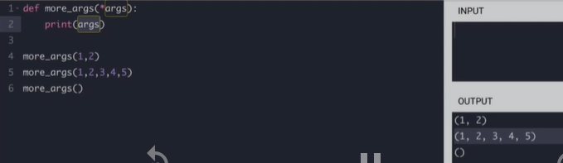

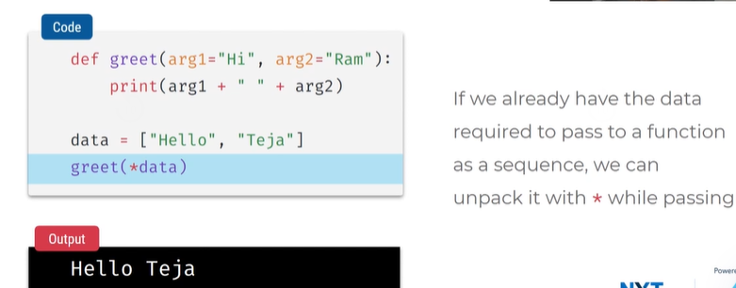

* Unpacking as Arguments
* Fun def lo default arguments set chesam like Hi and Ram
* Data list lo unnayi ,def fun lo pass cheyadaniki hello,teja
* Keyword arg kakaunda positional la pass cheyali ante just *data ani pedithe unpack avthayi arg_1 ki hello assign avthundi direct ga

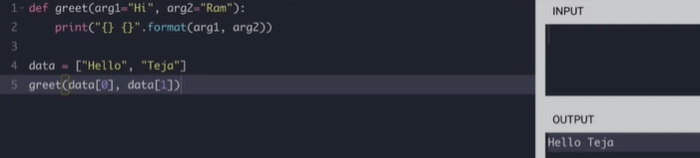

Greet(data[0] , data[1]) ela kakunda direct ga dynamic ga *data ante assign ayipothayi

*data ani pedithe positional arguments laga assign avthayi

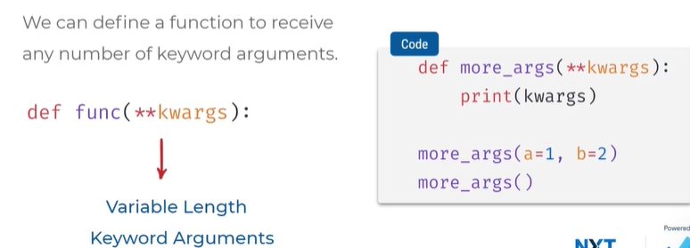

* Not like positional arguments we want them in keyword arguments then we use kwargs

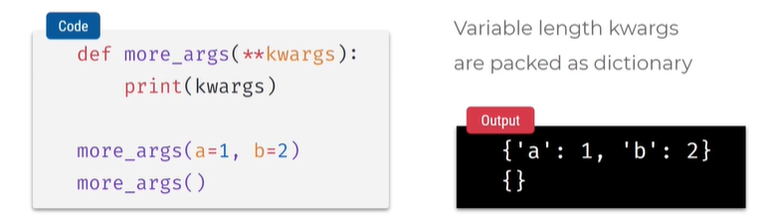

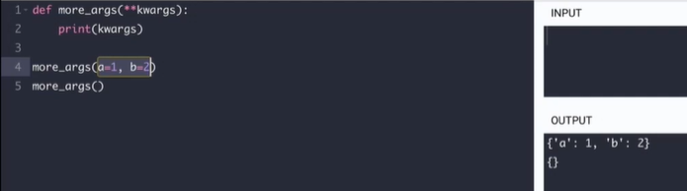

* Packed as dictionary
* K=key w=word args= arguments
* A keyword lo 1 b keyword lo 2
* Dic kabatti items meda iterate avvachu

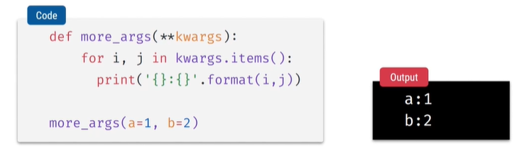

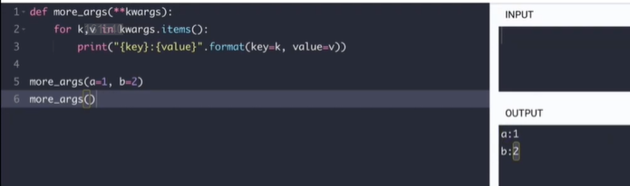

* i key j value assign avthundi
* can also give naming in {} in string format

muntiple arguments = *args

multiple keywords = **kwargs

Unpacking as arguments in dictionary:

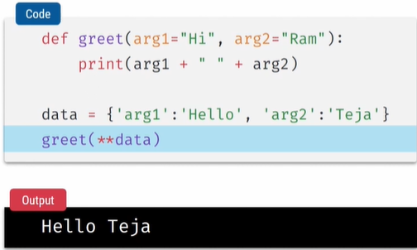

CALLING IN POSITIONAL ARGUMENTS

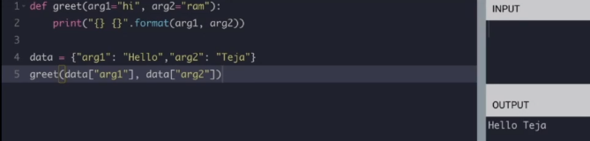

CALLING IN KEYWORD ARGUMENTS

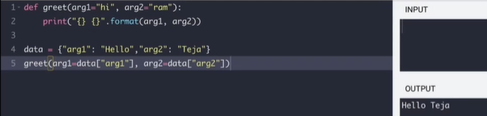

KEYWORDS POSITIONAL KI ANTHA CODE RASEBADHULU **data ante data ante dictionary or list lo unna key value pairs lo ekkdada keyword arguments kindha pass avthayi

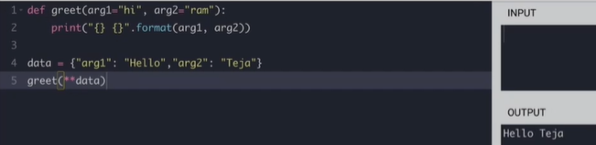

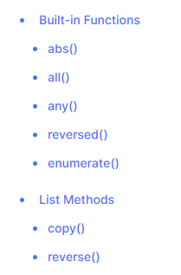

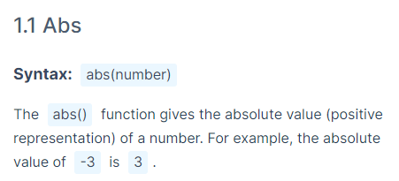

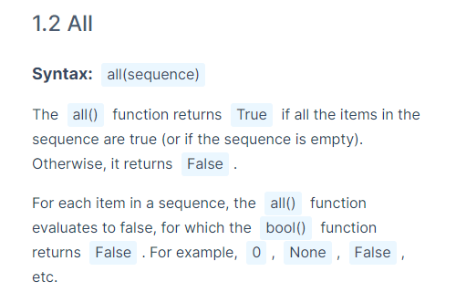

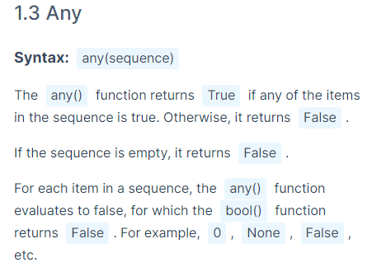

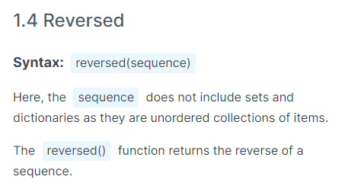

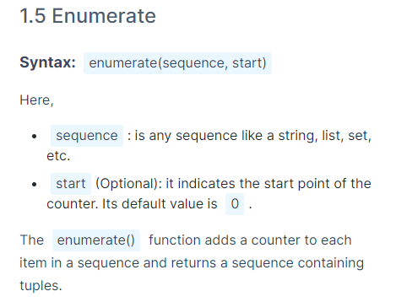

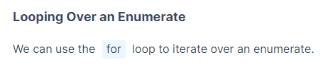

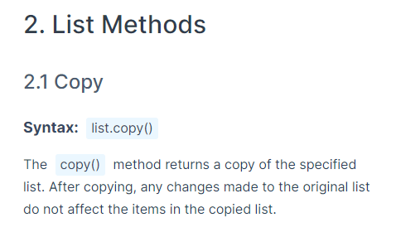

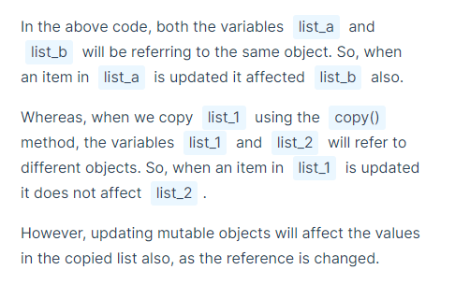

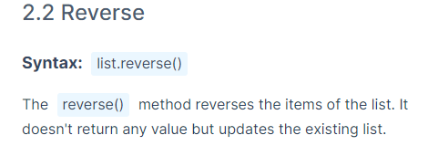

**OOPS = OBJECT ORIENTED PROGRAMMING SYSTEM**

* Object yokka related ga unna properties and values ni bundle chesthe encapsulation antaru
* Ala bundle cheyadaniki class ni use chestharu
* Init method lo arguments laga property ki unde values ni pass chestham self anedi vadali
* Actions function in inti method
* Properties = Attributes
* Actions = Methods
* blueprint = class
* details filled in class = instance
* object = collection of attributes, methods

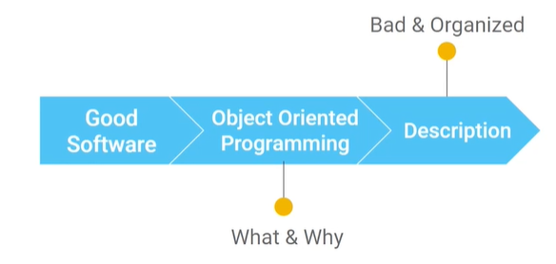

WE WILL LEARM:

**What is good software?**

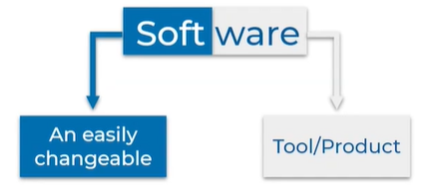

To build a good software we need OOPS

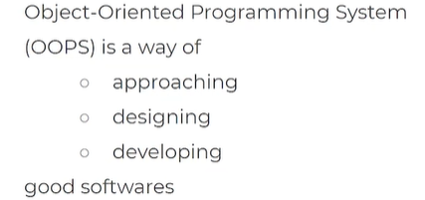

**What is oops?**

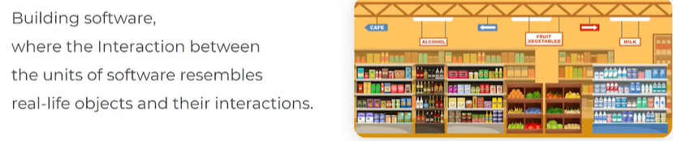

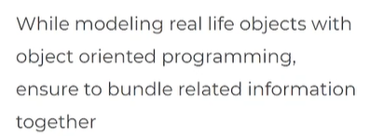

**Why oops?**

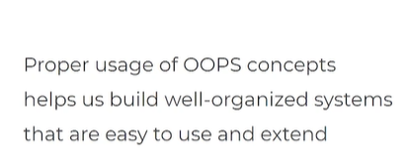

**Describing real life objects with OOPS?**

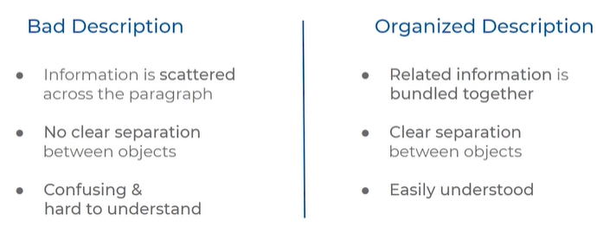

**What is bad & organized description?**

**Bad:**

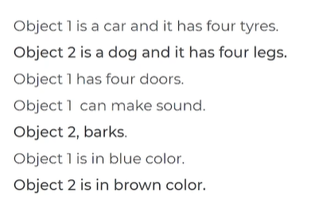

**Organized:**

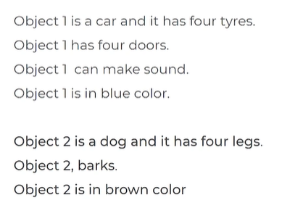

**Improving the organized description of objects**

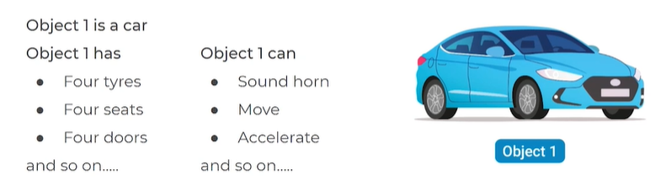

Em unnayi (what the car object has) = Properties and values

Em cheyagaladu (what car can do) = Actions

Objects has :

* Properties – values
* Actions

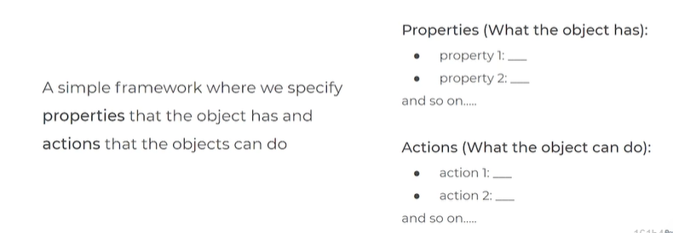

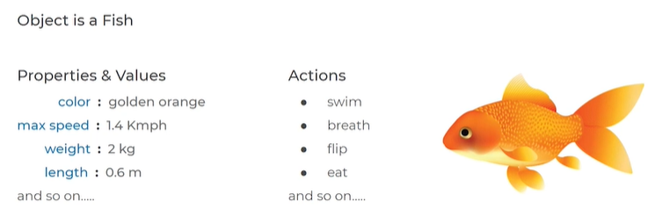



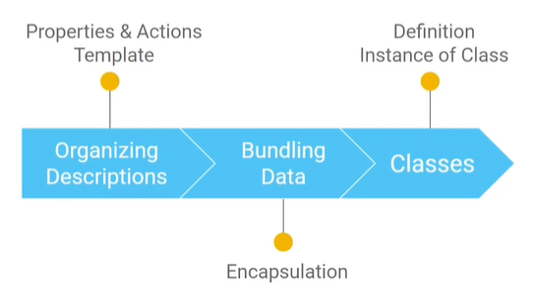

**Properties & Values in object :**

Properties same undachu kani properties ki assign ayina values change avthu untayi

We describe objects with form or template

**Encapsulation concept:**

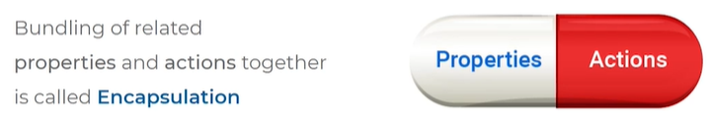

**Classes = Bundling data**

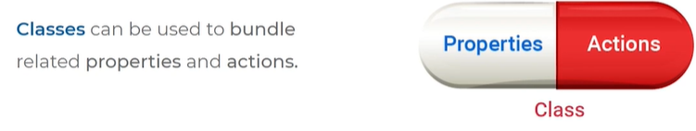

**DEFINING A CLASS SYNTAX:**

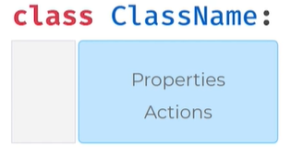

Class name should be unique

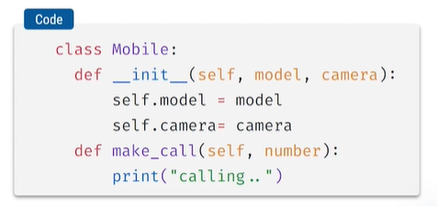

* __init__
* make_call

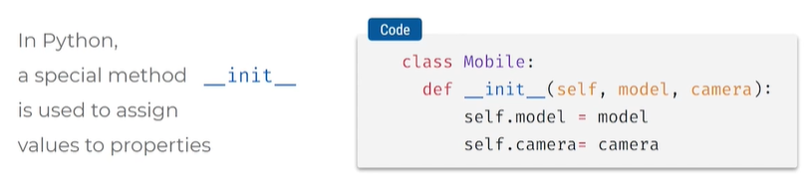

* object = Mobile
* oka object ni class tho describe chestham
* init anedi oka special method , spl method ante spl function, spl meaning undi ani ardham
* code lo brackets open chesi 1st arg self pettali, taravatha model,camera properties pettam
* ante brackets lo arguments laga values ni pass chesthunam
* properties ki values spl method arguments lo peduthunnam

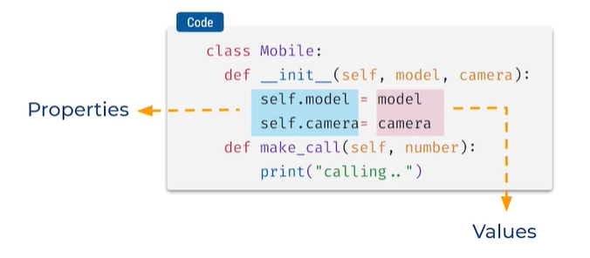

**Actions function:**

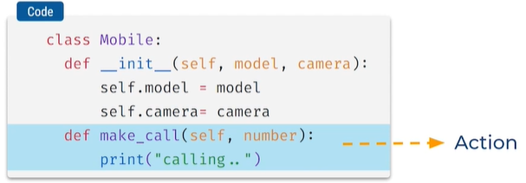

**Mobile ane object ki properties values icham , daniki action make_call**

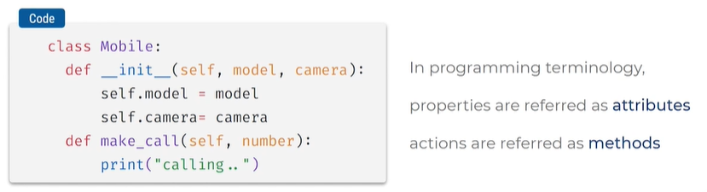

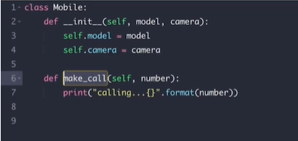

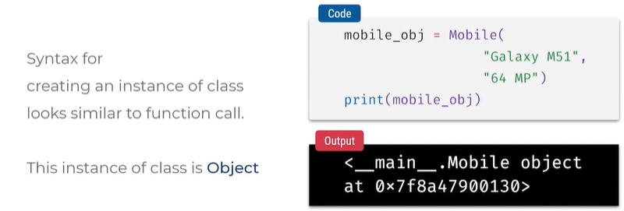

Mobile = class name

Oka class ki relate ayina instance ni create chesam

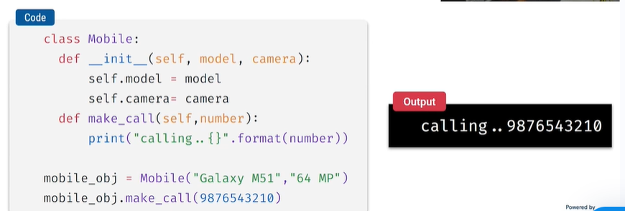

**CLASSES & OBJECTS**

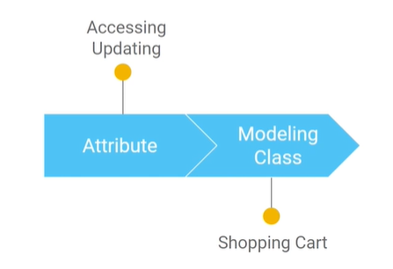

ACCESS ATTRIBUTES WITH NOTATION

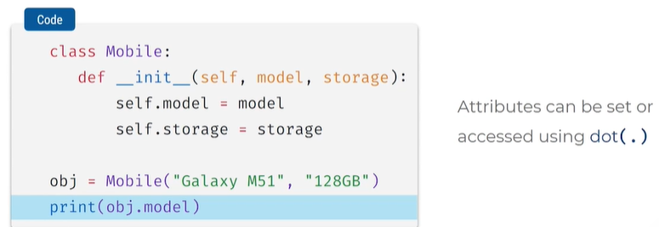

* Class ki manam oka object ni create chesi
* Oka instance ni create chesi
* Ah instance lo unna oka attribute ni dot notation tho access cheyachu

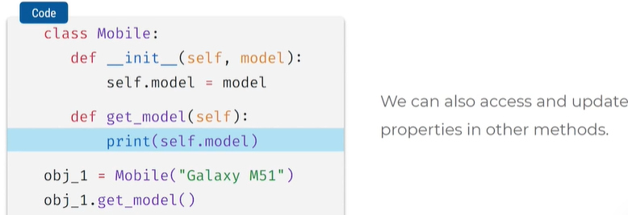

ACCESS FROM OTHER METHODS

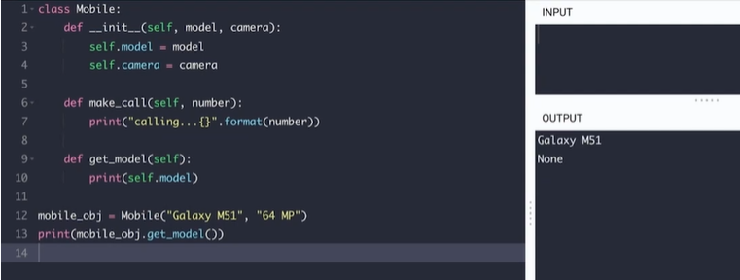

* Get model lo em return cheyatledu kabatti none vachindhi

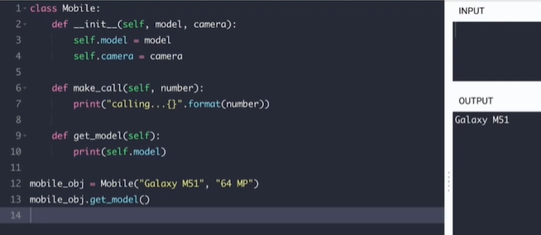

* Print thisesthe none pothundi model okate print avthundi

UPDATING ATTRIBUTES:

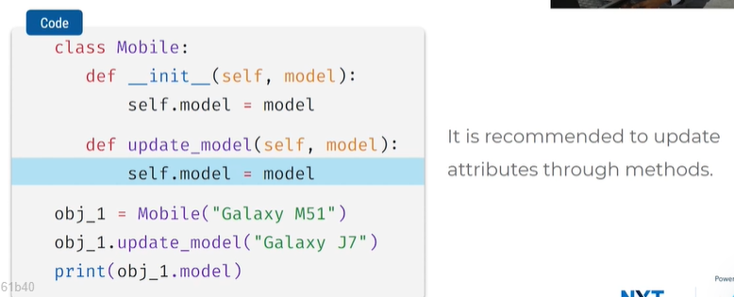

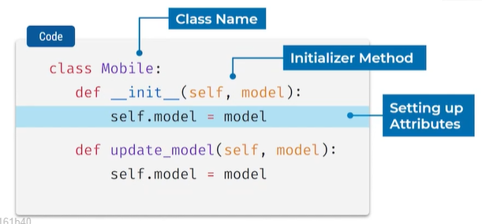

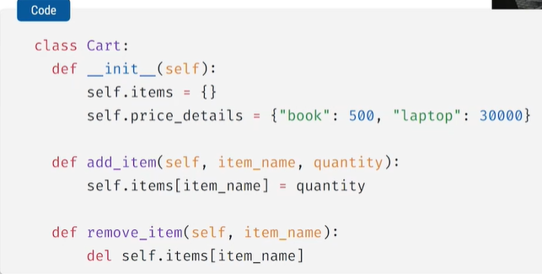

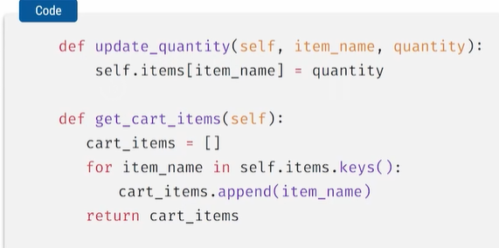

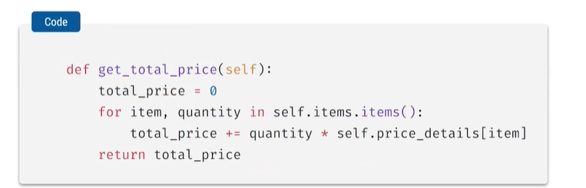

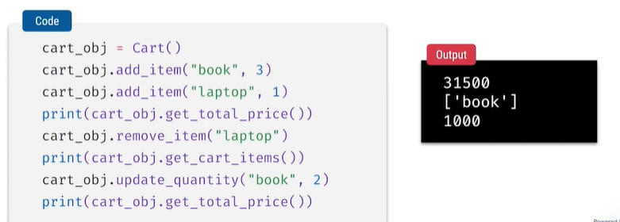

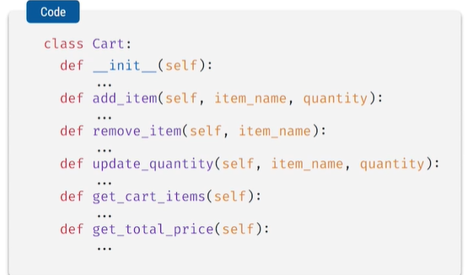

**ATTRIBUETS AND METHODS**

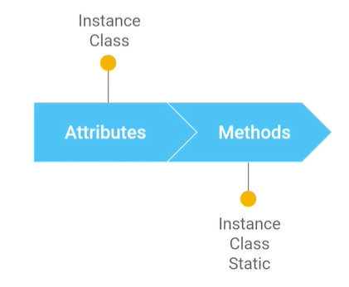

ATTRIBUTES:

* Class attributes
* Instance attributes

METHODS:

* Instance methods
* Class methods
* Static methods

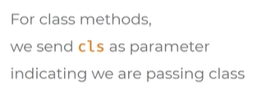

As an argument pass cls in class method

Cls ani pedithe cls ane argument ki value kindha class anedi pass avthundi

Class method ani define cheyadaniki @classmethod ani pedatham

Syntax:

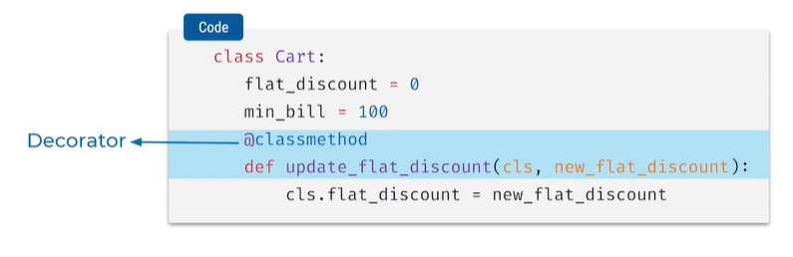

Cls.flat_discount ante cart.flat_disocunt ani rasinattu meaning

Decorator

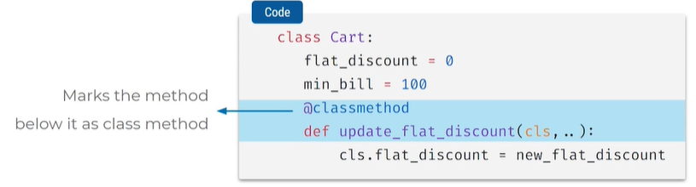

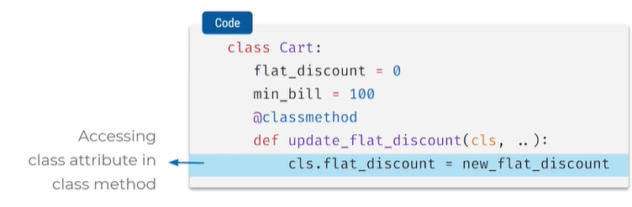

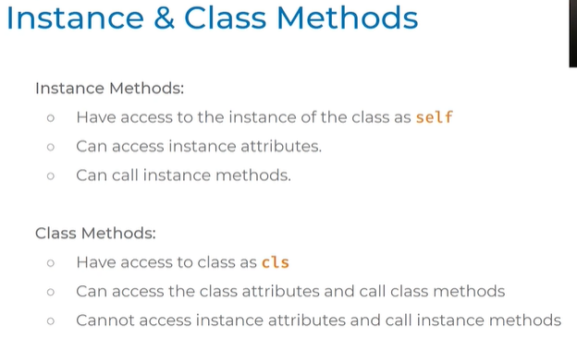

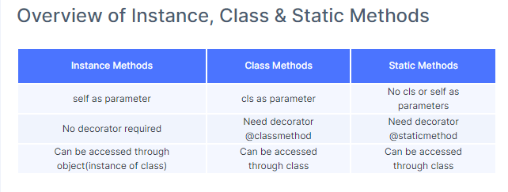

**INHERITANCE**

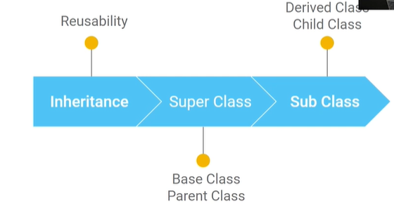

**Inheritance concept**

Epudu 2 items unnayi grocery item, electronic item:

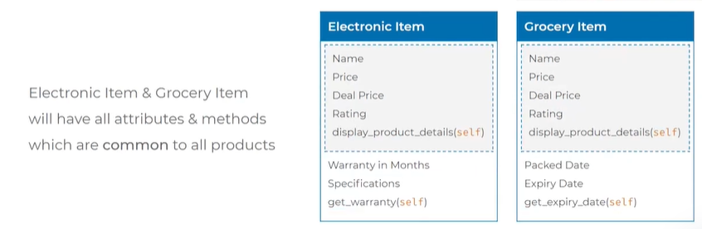

COMMON GA UNNA PROPERTIES NI SEPARATE OUT CHESTHUNNAM

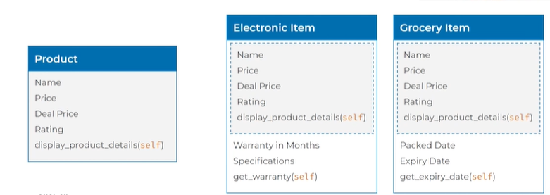

PRODUCT + GROCERY AYITHE COMMON GA UNNA PROPERTIES KAKUNDA

EVI KUDA ADD CHEYALI ELECTRONIC ITEMS LO AND GROCERY RENDITILO

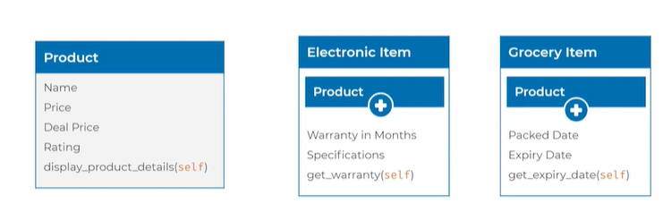

* Common ga unnavi separate out chesi
* Extra properties ni add chesi modeling cheyali

MODELLING HELPS IN:

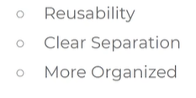

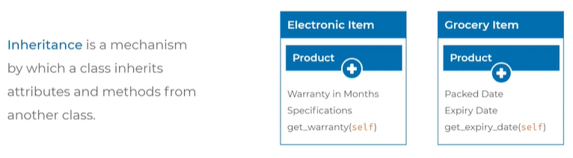

**implementation of inheritance in python**

**Syntax:**

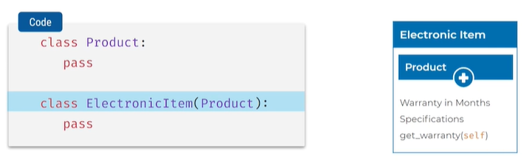

* Class product
* Class electronicItem(product)
* Paina product ane class create chesam kada adi electronicItem item lo pass chesam
* electronicItem ane class product ane class ni inherit chesthundi

**Achieve Reusability with inheritance**

**Super class = product**

**Sub Class**

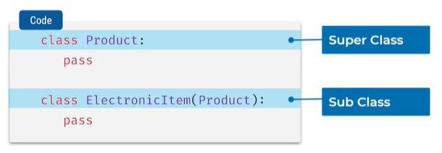

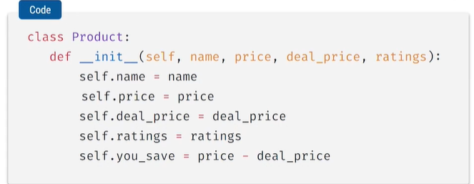

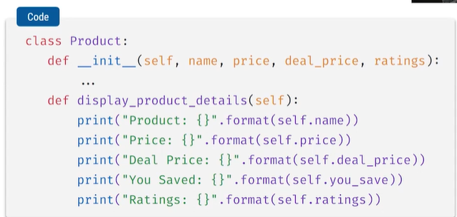

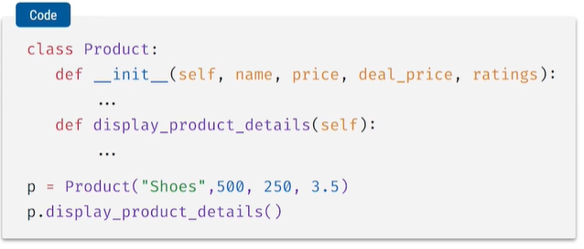

* p = Product("Shoes",500, 250, 3.5) = product lo details ni intialsie chesam
* p.display_product_details() = instance method ni call chesam
* parent class ni create chesam

**We call with different terminology like:**

* **Base class**
* **Parent class**
* **Derived class**
* **Child class**

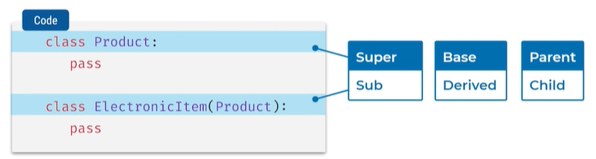

THIS IS PARENT CLASS:

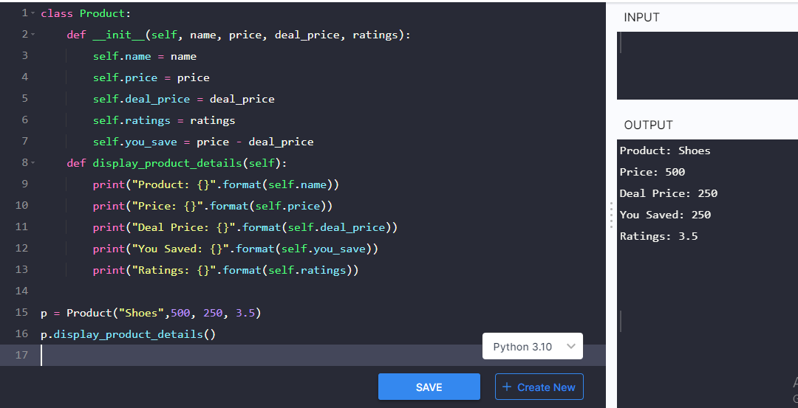

THIS IS SUBCLASS/ CHILD CLASS :

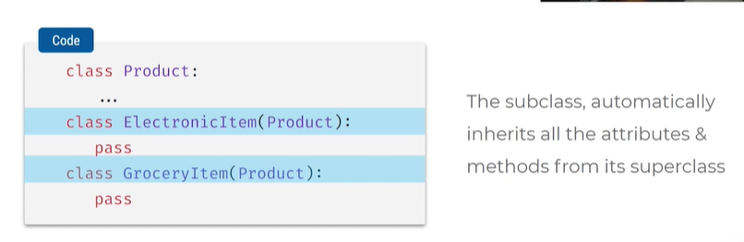

* Class electronic items ane class product ane class ni inherit chesthundi
* Next class grocery item same as above
* Creating instances in electronic items camera , 3000….

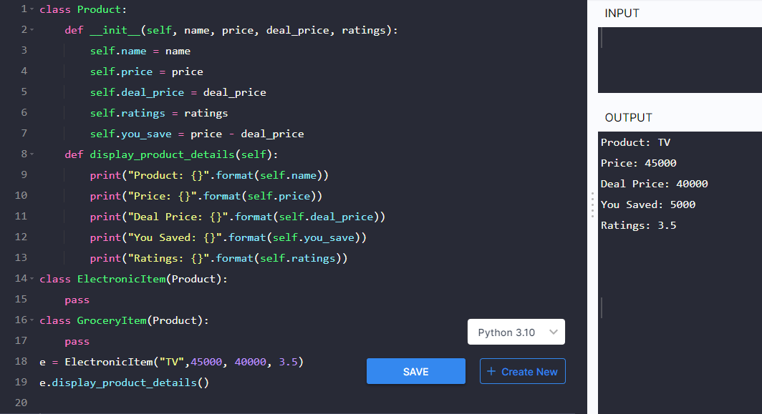

GROCERIES KI KUDA INTIALISE CHEYACHU

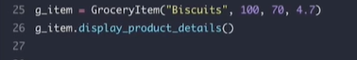

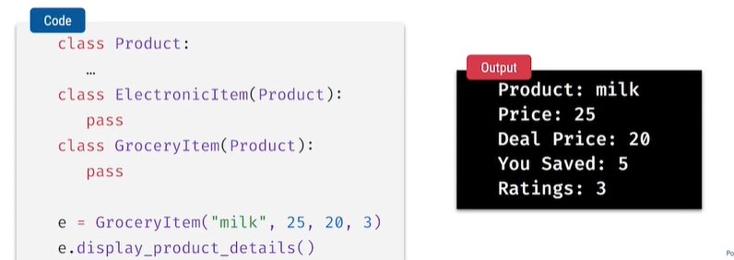

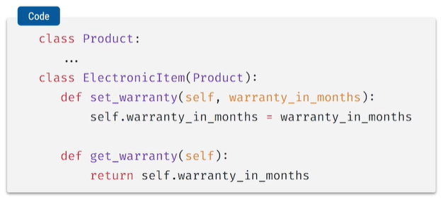

* Set warranty method
* Get warranty method

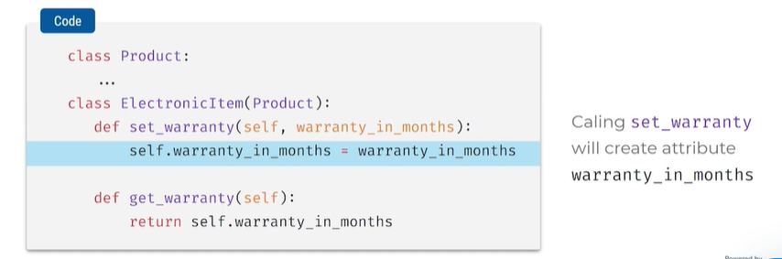

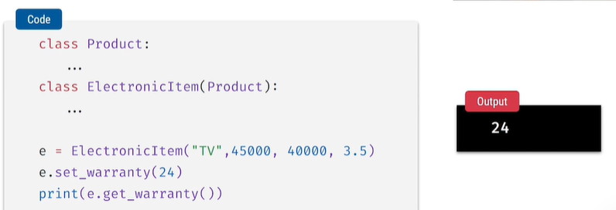

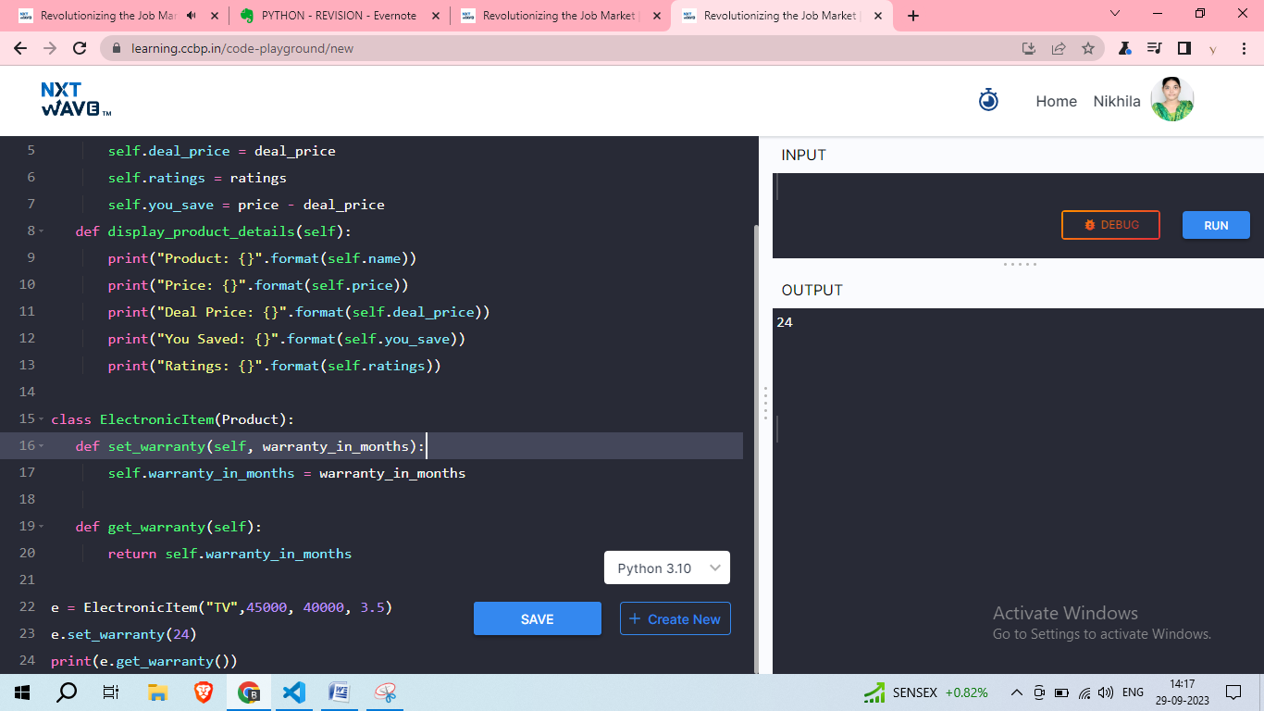

* 24 ki warrenty set chesam kabbati output lo 24 return ayindi

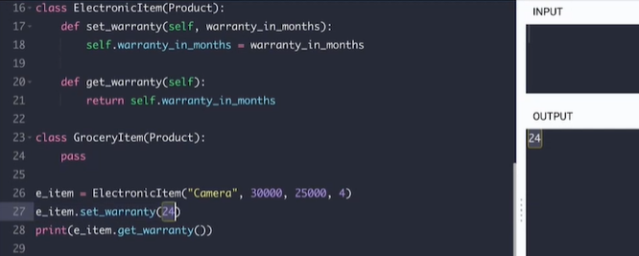

**new class (subclass or derived class)**

**existing class (base class or parent class)**

**inheritance is used to establish a relationship between classes, enabling code reuse and the creation of hierarchies of related classes.**

Inheritance allows you to create a new class (subclass or derived class) by inheriting properties and methods from an existing class (base class or parent class).

In the example: parentClass.py

* Product is the parent class
* Display_product_details is the method to display the details of the product
* Instance of product class is created and assigned to the variable p with values
* Display_product_details called on the p object

In the example: childClass.py

* Electronic item is the child class
* Inheritis the attributes and methods of product class

In the example: child class with two new methods

* Set warranty & get warranty are 2 new methods

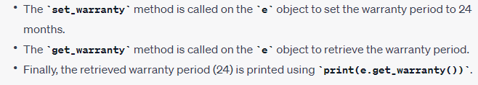

**INHERITANCE PART 2**

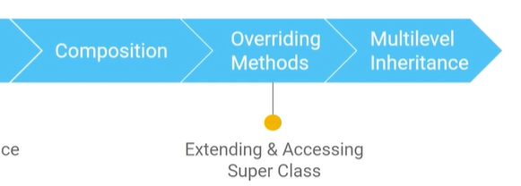

**COMPOSITION CONCEPT**

Product = parent class

Product attributes = name, price, deal price, ratings, you save

Product class methods = display product details, get deal price

Electronic item class = child class of product class

Electronic item 2 methods = get warranty, set warranty

Grocery item class = child class of product class

Order class = oka independent class , e class ki 3 attributes unnayi, 3 methods unnayi

Electronic item, Grocery item ki instances create chesam

Add item method use chesi milk , 2 ani values pettam order lo

Order lo em products unnayi vati details

Total bill

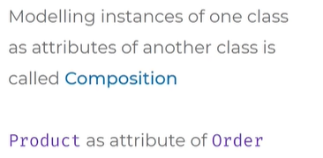

Composition ante oka class instance ni inko class yokka attribute ki value kinda pedithe danne composition antam

* Product ane class ki instances create chesam
* Tv, milk ani create chesam
* Order class add item lo values ki pettam danne composition antaru

**OVER RIDING METHODS**

* **EXTENDING**
* **ACCESSING**
* **SUPER CLASS**

**MISCELLANEOUS TOPICS**

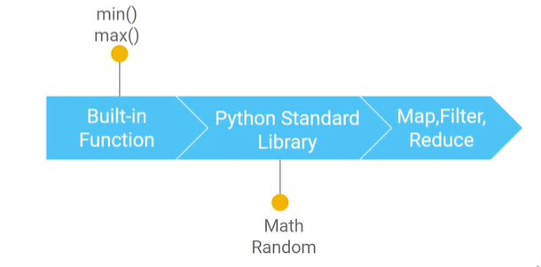

**BUILT IN FUNCTIONS**

**MIN()**

**MAX()**

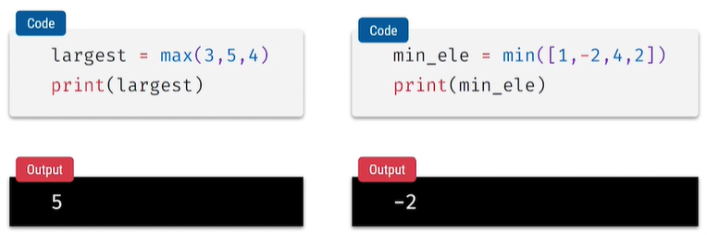

**PYTHON STANDARD LIBRARY**

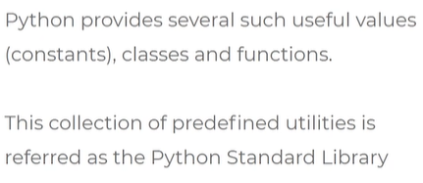

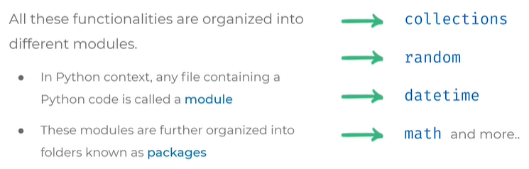

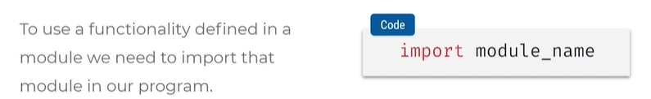

**MATH MODULE AND ALIAS CONCEPT**

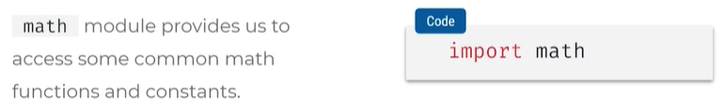

* To use math module import math
* Math ane module lo unna anni functions,class,variables import avthayi
* Kavalisna danne import cheyachu eg: from math import factorial
* Math lo factorial ni import cheyachu
* Pi function ni import cheyaledu kabatti name error vasthundi
* eg: from math import factorial,pi
* eg: from math import factorial as fac , fac name tho factorial ni use chesthanu
* as alias renaming math as m1
* To reuse we will use m1 instead of name math

**MATH MODULE SYNTAX:**

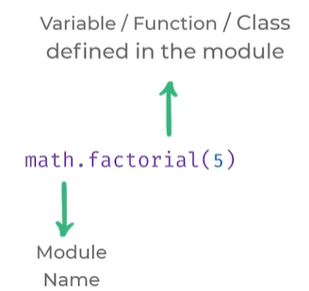

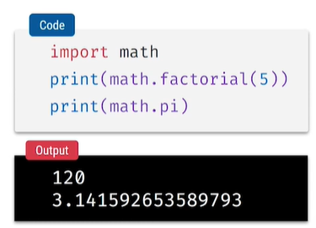

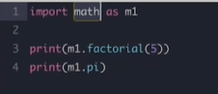

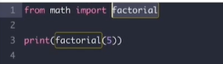

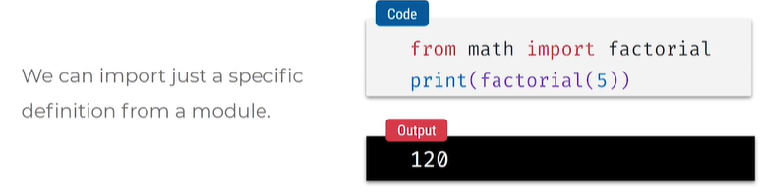

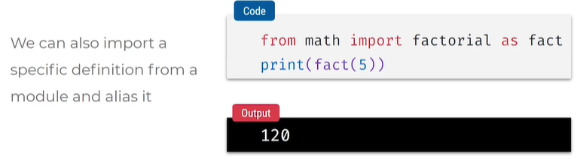

**RANDOM MODULE**

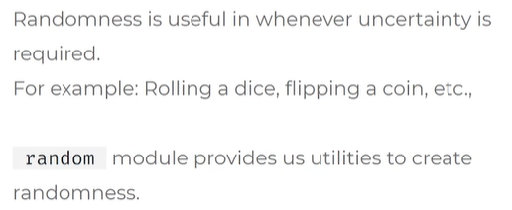

* Random value
* Random functions , classes, values

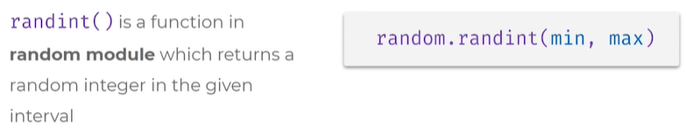

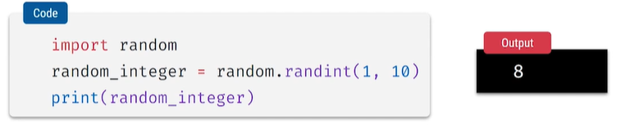

* Randint(1,10) annapudu prathisari oka random value vasthadi
* Kotha value vasthadi run chesina prathi sari

**CHOICE FUNCTION IN RANDOM MODULE:**

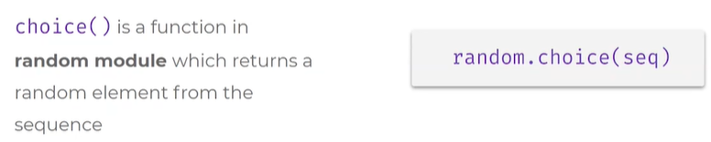

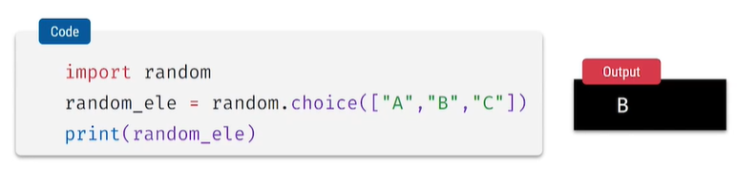

* Random module lo choice use chesam so values differ ayyi random ga vasthayi
* Seq lo unna ele random ga vasthayi

**TO STUDY MORE ABOUT PYTHON STANDARD LIBRARY**



**MAP FUNCTION**

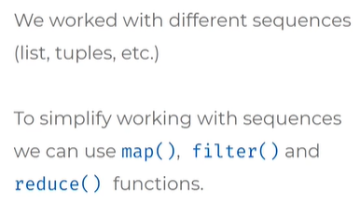

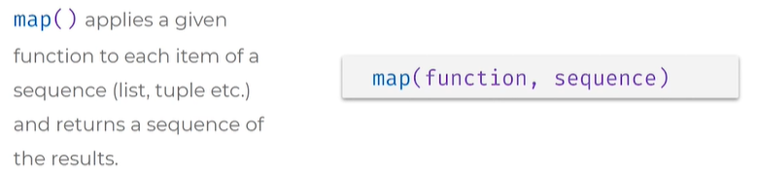

* Seq lo prathi element pass chesina function loki velli execute avthundi

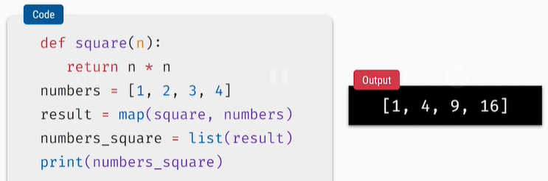

* Square anedi function
* Argument n
* Return squar en *n
* Number lo list undhi
* Result lo map of square , numbers square ante func name , numbers ante list seq
* We are converting into list object
* Function, seq kada function ante square, seq ante numbers

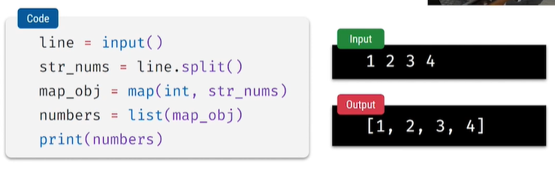

Int,string la vasthundi input integer la marchamu

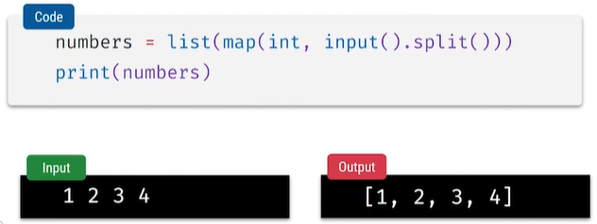

**FLITER METHOD**

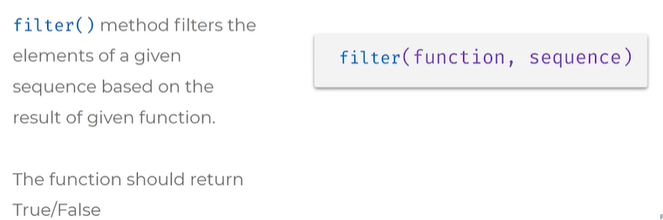

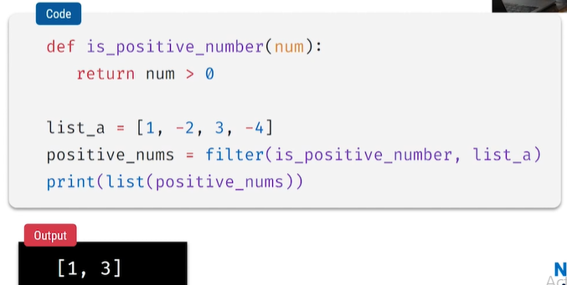

**REDUCE FUNCTION**

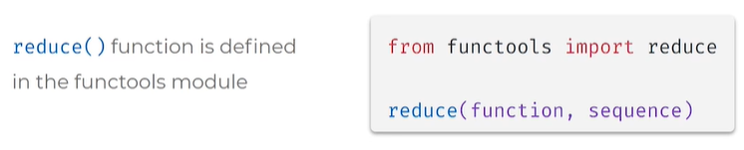

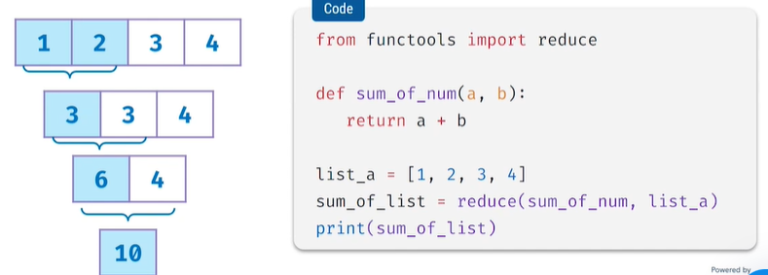

**ERRORS AND EXCEPTIONS**

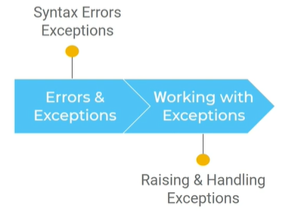

Errors

Types: syntax errors and exceptions

Syntax errors = rules of language is not followed properly

Exceptions = errors with proper syntax, piece of code execute aye time lo vache errors

Particular line execute aye time lo vache error ni exception

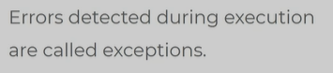

**WORKING WITH DATES & TIMES**

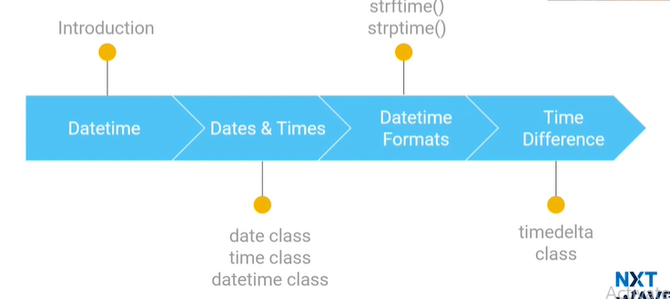

**DATE TIME:**

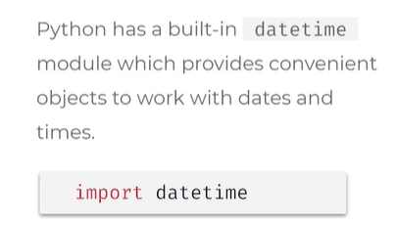

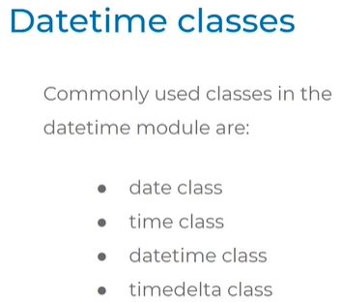

**Dealing with dates**

**Dealing with Times**

**Dealing with both Date and time**

**Dealing with different Times**

**Date class**

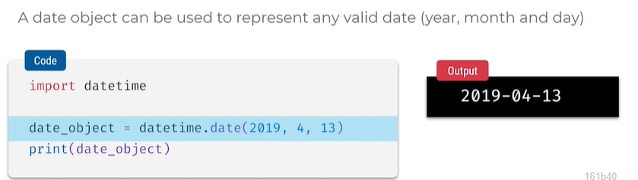

**VALID DATE TIME IVVAKAPOTHE VALUE ERROR VASTHUNDI**

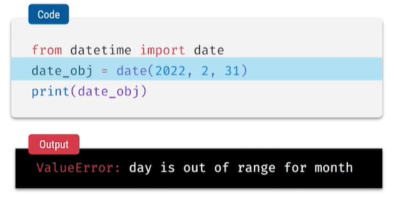

**Today method in date class**

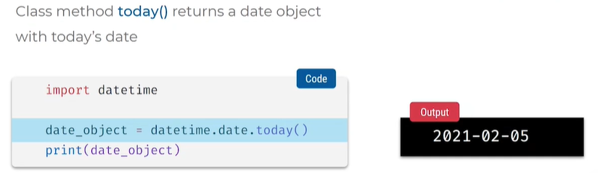

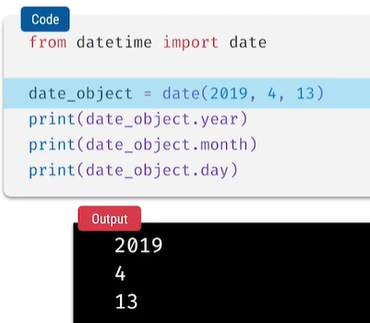

**Dealing with Times**

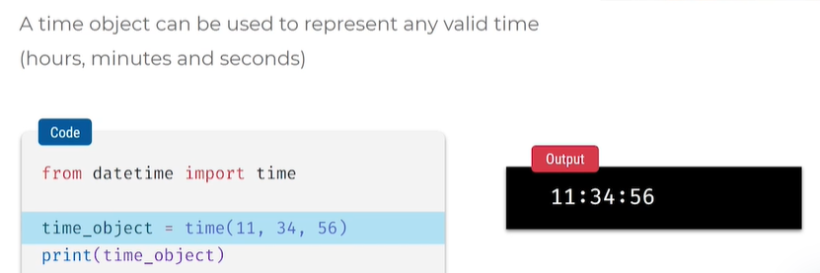

**Dealing with both Date and time**

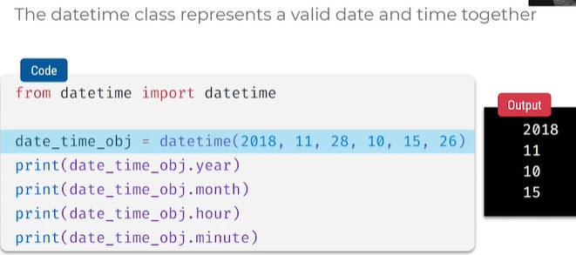

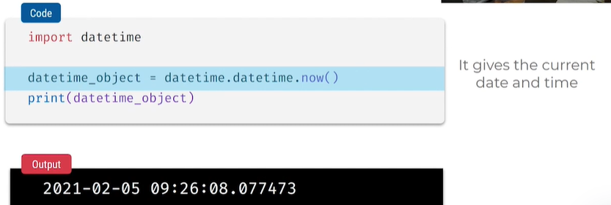

**DATE TIME FORMATS**

**Strftime() method = ey format lo kavalo ah format istham**

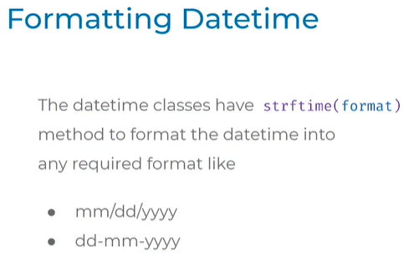

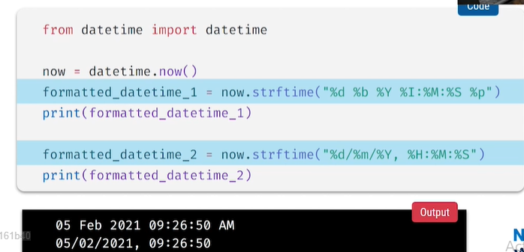

Strptime() date time object nu chi string create chesam

Strftime() string numchi date time object create chestham

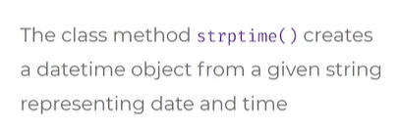

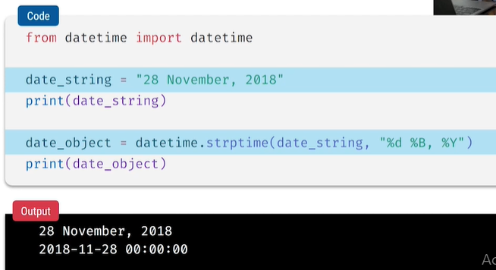

**TIME DELTA CLASS**

**DURATION BETWEEN TIMES USE TIME DELATS \**

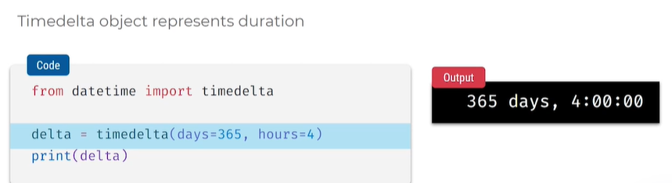

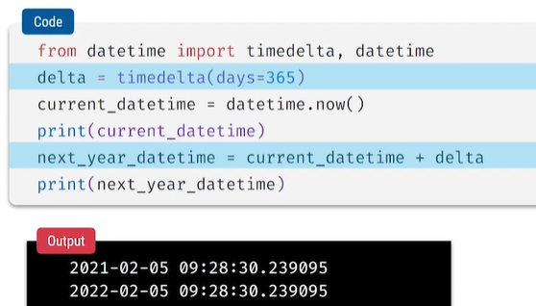

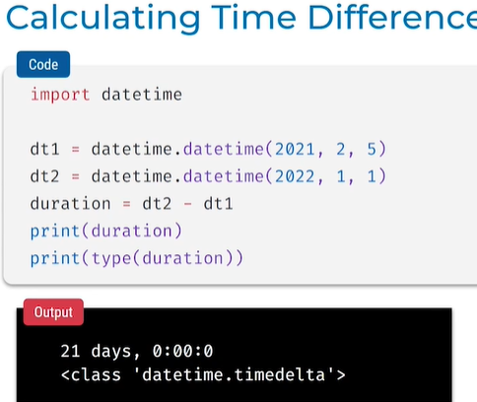

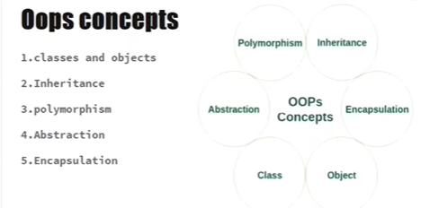

**Class = blue print of object**

**Inheritance = vamsa para paryam , they are various types in inheritance**

**Polymorphism = many forms**

**Abstraction = data hinding**

**Encapsulation = binding of data and data methods**

**CLASS AND OBJECTS**

**Keywords: self, init**

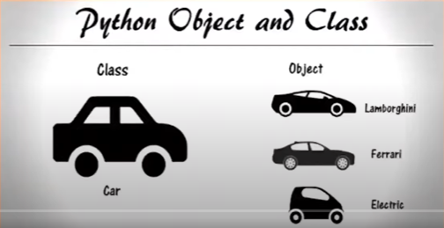

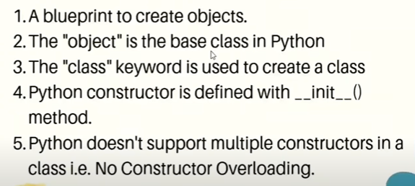

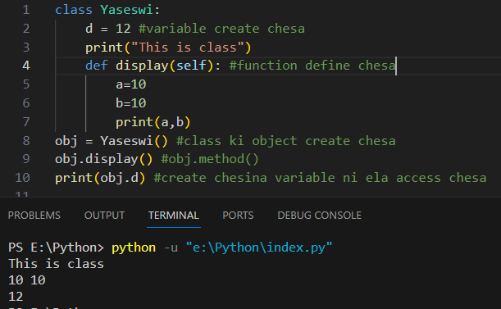

**__init__ method variables ni intialse cheskundati ela ante self.model , self argument pakka undali**



**Parents class lo = function/variables kani declare chesthe**

**Child class nunchi = access cheyachu**

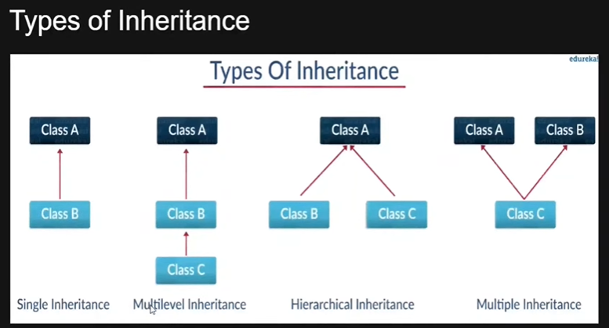

**Single inheritance = parent nunchi child ki oka class**

**Multilevel inheritance = level – by – level grandfather –son-child**

**Hierarchical inheritance = oka parent idhari pillalu, idharu pillalu amma ni vidi vidi ga piluchu kovali**

**Multiple inheritance = 2 parents nunchi oka child ki ,**

**Super key word =**

* Class A and class B
* Function define chesam init method thiskoni
* Class A lo init class B lo init
* Class B ni A tho inherit chesa , inherit chesthe class A lo unna properties class B loki ravali
* Obj class B ki create chesthe b lo unnadi matarme vasthundi
* Class a ki kuda create cheyali class b lo super keyword use cheyali class a lo unnavi class b lo access avvali ante super keyword use cheyali
* Super().__init__()

**POLYMORPHISM:**

* Multiple forms or more than once

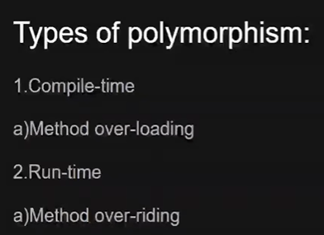

Okate class lo same method name undi different parameters unte Danni method overloading antam

Run time/dynamic

Diff class same names diff parameters

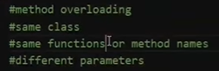

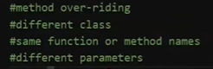

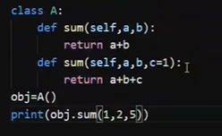

* Same class = class A
* Same function name = sum
* Diff parameters = a,b and a,b,c
* Obj create chesi print chesthe last function ey thiskoni error vasthundi
* E error ni overcome cheyali ante default ga parameter pass cheyali
* Apudu error pothundi
* Oka vela print chese time lo value pedithe default ga pettindi care cheyadu

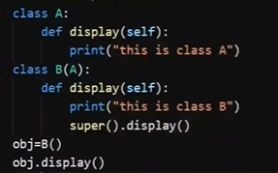

* Diff class = class a and class b
* Same functions name = display and display
* Diff parameters = in print
* Object create chesthe only class b ey vasthundi
* Class a kuda kavali ante class b lo super keyword pettalu
* Display function call chesthe rendu classes vasthayi

**ABSTRACTION:**

**ENCAPSULATION:**